George Elwood Smith

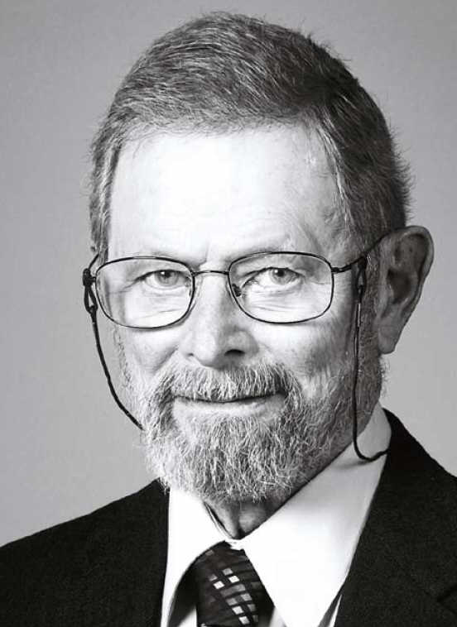

George E. Smith was born in White Plains, New York, in 1930. He received the B. A. in Physics from the University of Pennsylvania in 1955, the M. S. and Ph. D. in Physics from the University of Chicago in 1956 and 1959 respectively.

Following graduation, he joined Bell Laboratories (1959) where he initially studied the electrical properties and band structures of semimetals, mostly bismuth and bismuth antimony alloys. These studies were largely microwave resonance experiments and investigations of a variety of magnetothermoelectric and galvanomagnetic effects. In 1964 he became Head of the Device Concepts Department, a group formed to devise next generation solid state devices. In this capacity, he was involved in a variety of investigations including junction lasers, semiconducting ferroelectrics, electroluminescence, transition metal oxides, the silicon diode array camera tube, the silicon floating gate nonvolatile memory cell and Charge-Coupled Devices. In April 1986 he retired from his position at Bell Laboratories as Head of the VLSI Device Department where his responsibilities covered the physics of devices made with submicron lithography and their use in high performance digital and analog circuits

Dr. Smith has been a member of Pi Mu Epsilon, Phi Beta Kappa, and Sigma Xi. He was made a fellow of the Institute of Electrical and Electronic Engineers, Fellow of the American Physical Society and a member of the National Academy of Engineering. He holds 31 US patents and is the author of over 40 papers. He was founding editor of the IEEE publication “Electron Device Letters”

Smith's major technical accomplishment was the inception of the Charge Coupled Device with Willard S. Boyle. They hold the basic patent (US 3,858,232) and published the first paper disclosing the device concept (1) accompanied by a paper on its experimental verification (2). A following invention of the Buried Channel Charge Coupled Device (US patent 3,792,322) significantly improved the performance of the original CCD. Their accomplishment has been recognized in the following awards:

1973 Ballantine Medal of the Franklin Institute
"For the invention of the charge-coupled device structure, a conceptually simple semiconductor technology with significant application to image sensing, serial memory and signal processing."

1974 Morris N. Liebman Award of the Institute of Electrical and Electronic Engineering "For the invention of the charge -coupled device and leadership in the field of MOS device physics."

1986 Progress Medal of the Photographic Society of America
"For the charge-coupled devices applications to electronic imaging devices."

1999 IEEE Device Research Conference Breakthrough Award
“For pioneering work in the field of Buried-Channel Charge Coupled Devices”

1999 Computer and Communications Prize
“For the Invention of the Charge Coupled Device (CCD)”

2001 Edwin Land Medal
“For the invention and development of the Charge-Coupled Device, a contribution that has had extraordinary impact on image creation and utilization”

2006 Charles Stark Draper Prize
“For the invention of the Charge-Coupled Device (CCD), a light-sensitive component at the heart of digital cameras and other widely used imaging technologies.”

2009 Nobel Prize in Physics
“For the invention of an imaging semiconductor circuit – the CCD sensor”

