Towards composable robotics: the R3-COP Knowledge-Base driven Technology Platform
E. Schoitsch, W. Herzner (AIT, Austria), C. Alonso-Montes (Tecnalia, Spain),
P. Chmelar (TU Brno, Czech Republic), Lars Dalgaard (DTI, Denmark)
{erwin.schoitsch, wolfgang.herzner}@ait.ac.at
carmen.alonso@tecnalia.com, chmelarp@fit.vutbr.cz, ldd@teknologisk.dk
Abstract. The ARTEMIS project R3-COP (Resilient Reasoning Robotic Co-operating Systems) aims at providing European industry with leading-edge innovation that will enable the production of advanced robust and safe cognitive, reasoning autonomous and co-operative robotic systems at reduced cost. This is achieved by cross-sector reusability of building blocks, collected in a knowledge base, within a generic framework and platform with domain-specific instantiations.
The R3-COP Framework is targeting at robust autonomous systems by embodying methodologies, methods, and tools for safety-critical hard-real-time system development and verification supported by European tool vendors. To enable this, interoperability issues have to be resolved at several levels, including meta-models, models, tool interfaces and component descriptions. The link is established by the knowledge base described in more detail in this paper to allow composition of robotic applications from building blocks, guiding design & development as well as validation & verification (supporting certification in the end). The concept of the knowledge base could be re-used in the planned ARTEMIS Common Reference Technology Platform for critical systems engineering.
Keywords: robotics, autonomous systems, co-operative systems, composability, building blocks, ontology-based knowledge base, reference technology framework, safety, cognitive systems, robotic vision, testing, certification.
- Introduction
R3-COP (Resilient Reasoning Robotic Co-operating Systems) aims at developing and implementing a generic framework and platform with domain-specific instantiations which will facilitate the production of advanced robust and safe cognitive, reasoning autonomous and co-operative robotic systems (mobile and immobile) at reduced cost. This will be achieved by enabling cross-sector reusability of building blocks, collected in a knowledge base, which is part of a technology platform and framework and contains the required information on how ARS (Autonomous Robotic Systems) methods, components, subsystems and systems work and interact with each other and what characteristics they have. This addresses the interoperability issues of building blocks (meta-models, models, components and interfaces) and tools to be provided within the R3-COP framework.

Besides creating the knowledge data base (structure, description of characteristics of building blocks, interfaces), R3-COP creates a portfolio of methodologies to be used and a tool box of architectural frameworks, guidelines and tools necessary to apply the information from the knowledge base in specific design contexts in order to arrive at a viable solution for an autonomous robotic systems problem. The primary goal within the project will be to provide a solution that can be applied directly to the projects’ use cases (ground-based, airborne and underwater, including applications from manufacturing, home appliances, surveillance, inspection, manipulation, transport etc.). Generalisation and flexibility are considered as secondary goals. The knowledge base is for reasons of practicability and parallel development of methods and tools for design & development (1) as well as for validation & verification (2) split in two parts accordingly.
- The R3-COP Concept: Framework and Interoperability
The overall goal of R3-COP is to improve the quality of robotic systems and to increase trust in the systems by composable design and by developing new test strategies for mobile and adaptive (co-operating) systems with complex sensor input (e.g. stereo vision) and autonomous behavior, with measurable coverage of sensorial information and behavioral aspects, based on in-depth domain analysis. In detail, the target research areas are:
- Design and development: model-driven process for the compositional development of safety critical (mobile) systems
- Analysis Methods: System analysis and evaluation are addressed in context of safety cases
- V&V (Validation & Verification): new test strategies, methods and tools for vision-based perception and (co-operative) behavior of (mobile) autonomous systems
- European Standard Reference Technology Platform (Framework): utilizing results and experiences of recent European projects, the framework is targeting at a European RTP for robust autonomous systems
- Qualification, standardization and certification support issues
- Cross domain applicability: The framework knowledge base covers all domains and enabling technologies for autonomous systems (transport, automation, surveillance, co-operation, emergency services on ground, underwater and air)
R3-COP focuses, in particular, oon design & development level in providing components as building blocks for robotic autonomous systems (compositional design), including positioning, navigation and communication, as well as on very specific problems of assessing correctness, safety and robustness of autonomous robotic systems in developing new V&V methods and tools (analysis and test) for complex sensors and perception modules, and co-operative behaviour. These artifacts are collected in a Knowledge Base in a standardized manner (see Fig. 1), which requires a common interoperability definition with respect to interfaces and attributes. R3-COP will achieve its goals by
- developing a design methodology (reference architecture) with means for tailoring it for specific applications. It will be substantiated in a number of domain-specific platforms and demonstrators, including cross-domain co-operating systems,
- developing innovative system components for the robust perception of the environment including sensor fusion, and for reasoning and reliable action control,
- developing a fault-tolerant high-performance processing platform, based on a multi-core architecture.

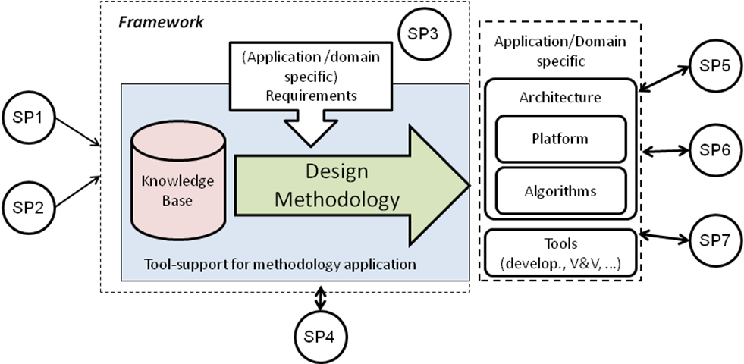
Fig. 1: The R3-COP Framework concept: The knowledge base enabling composition of robotic applications (SP1, SP2 provide foundations and new specific robotic/autonomous systems features, SP3 and SP4 are developing the D&D and V&V methods & tools,. SP5-SP7 are applications/domains)

An important goal of R3-COP is the establishment of a “knowledge base” for autonomous and robotic systems, using ontology for knowledge description and taxonomy, consisting of two parts:
- “design & development” (DDKB): supports the Design &Development (DD) methodology by providing information about hard- and software components, their purpose, costs, strength and limits, possible combinations or conflicts etc.
- “validation and verification”: supports the V&V process by providing information about analysis and test tools applicable for robotic components, their purpose, costs, strength and limits, possible combinations or conflicts etc.
Design & Develop-ment
V&V
(Analysis & Test)
R3-COP Knowledge Base
CRTP
pSafeCer MBAT, …
r
MBAT
Design & Develop-ment
V&V
(Analysis & Test)
R3-COP Knowledge Base
CRTP
pSafeCer MBAT, …
r
MBAT
Design & Develop-ment
V&V
(Analysis & Test)
R3-COP Knowledge Base
CRTP
pSafeCer MBAT, …
r
MBAT
- The Knowledge Base for Design & Development (DDKB)
Briefly, an Autonomous Robotic System (ARS) is made for the purpose of performing some task (e.g. surveillance, vacuum cleaning or some kind of a mission) within the operating environment (e.g. ground, underwater or airborne) under given set of requirements (both functional and non-functional). Thus, the ARS design process can be expressed as a process to find a solution for a problem with a set of “robots” performing the task under some conditions.
The ARS design process is accomplished with the problem statement, analysis, engineering design, production and some post production activities in a systems engineering life-cycle including verification and validation in each step. In R3-COP, the designs are supported by the knowledge base, which includes the aggregated use-cases and design patterns used by the project partners and suggested as best practices. These can be used by other designers as a recommendation of components, methods, tools and tool chains.

This is supported by the knowledge base in two equivalent ways:
  - In a human-readable Wiki-based hypertext representation supported by a search engine and a classification scheme is used to locate information in the system as illustrated in Fig. 2.
  - In a machine-readable logically consistent form. The ontology defines the structure of the data – types of entities and their relations represent the knowledge necessary to apply automated deductive reasoning (see Fig. 3). This is important for interoperability – to have a standardized format for description of entities (components) and their relations. The ontology browser uses WebProtégé.
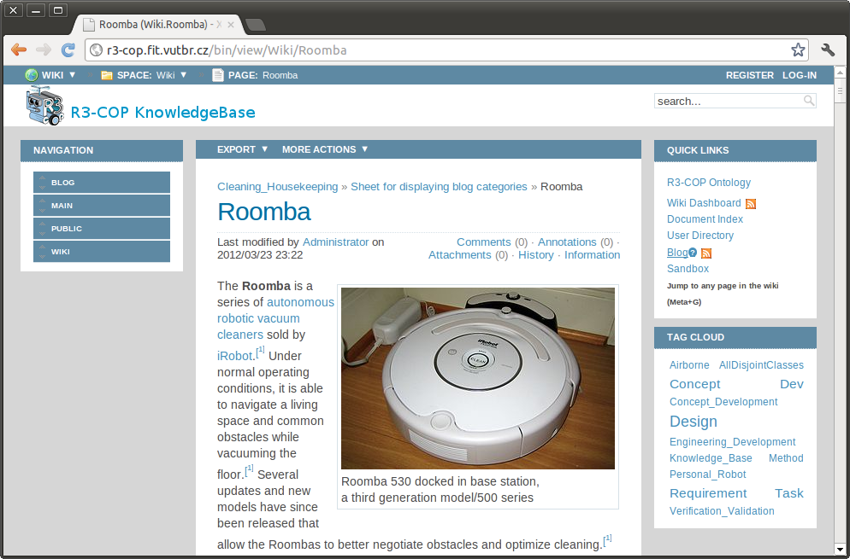
Fig. 2: The R3-COP knowledge base Wiki including the tag cloud classification scheme.

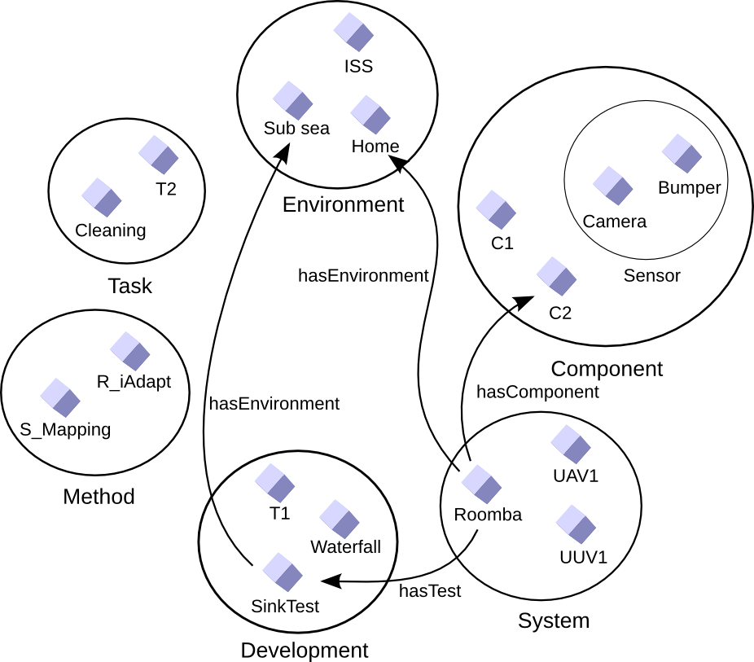
Fig. 3: The R3-COP ontology illustration of individual entities organized in sets – classes and connectors using property relations.
- The Knowledge Base for V&V (VVKB)
The main idea behind the VVKB is to provide help to any user (independently of their V&V knowledge) in the identification of the most suitable V&V technique to be applied to during the robot development or afterwards.

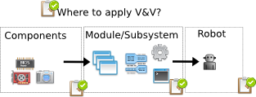
Fig. 4: The V&V techniques shall be applied to components (touch sensors, cameras, laser, etc), SW modules or subsystems that implements an specific functionality, and finally, the complete robot (formed by the previous elements)

The inherent complexity of the robot makes it difficult to apply a unique V&V technique for the complete robot. So, different V&V techniques need to be applied for different elements, at different stages of the design phase, and of course, to the complete robot. Each component, subsystems and systems shall be independently tested and validated, and of course, the final robot, which is a composition of the previous systems, shall be also tested as a whole. So, the need of a Knowledge Base (KB) to describe potential techniques to test each part or the whole system, reducing the number of possibilities, is the first step towards a complete automation in the process of application of V&V techniques. Here a shared interest with ARTEMIS project MBAT is envisaged; if certification is the final goal, composable certification is an issue where co-operation with the SafeCer is planned (e.g. via a joint workshop on certification).
The general strategy can be seen on the right side of Fig. 5. The ultimate goal would be that any user (expert or non-expert) that would like to know which kind of V&V techniques can apply to his robot development could search through the R3-COP ontologies with an “intelligent and semantic search”.
A specific VV ontology provides the mechanism of the search tool for accessing the corresponding VV concepts, so the reasoning process will be formalized based on ontological concepts. A particular search will return a set of possible V&V candidate techniques that fits the parameters of the search. So, the user will have at least a reduced set of possible choices that in some way have been proved as a good option for that particular problem. Notice that the repository will be fed by the information provided from the analysis done for the domains and use cases, and some specific content can be inferred from concepts of the VV ontology. Hence, the information returned to the users will be twofold enriched: general information coming from human expert analysis and some other inferred information, taken from the VV ontology.
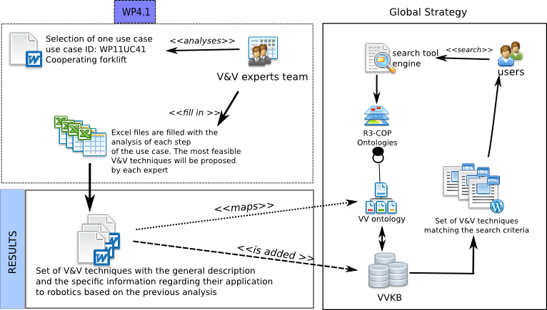
Fig. 5: Relationship among the results of V&V WP and the global strategy behind the ontology proposal (the mentioned use case is taken as an example)

Each candidate technique is shown to the end user following a predefined structure, containing general information, human analysis information and inferred information from the ontology. The candidates have to be described in a comparable manner, so again interoperability is a key issue. For this purpose, a preliminary form has been defined in order to unify the presentation to the users. Each individual V&V technique is described in this standardized format and stored in the VVKB. The general parts can be split up into several sections: general, human expert analysis, inferred information. The general information corresponds to the general descriptions of the technique: name, description, type, category, benefits and limits. The human expert analysis will be added in two sections: relationship with challenges of ARS, and others. Initially, this content is influenced by the analysis of the current R3-COP use cases, but will be growing with new usages in other scenarios, following the collaborative way of working in Wikipedia. This was already indicated before as the RTP was referred to as on-line resource for the autonomous systems community in the future.
Some additional information can be directly inferred from the concepts stored within the particular ontology for VV and the others used in R3-COP. This information is automatically generated from the information in the form (“inferred elements from the ontology”-section). In this section is shown in which types of “robot tasks” (navigation, grasping, movement, etc.) a particular V&V technique has been used. The same reasoning process can be applied to “features” and “environment”. In Fig. 6, the relationship among the contents of the Wikimedia document and both the ontology and the VVKB are shown.

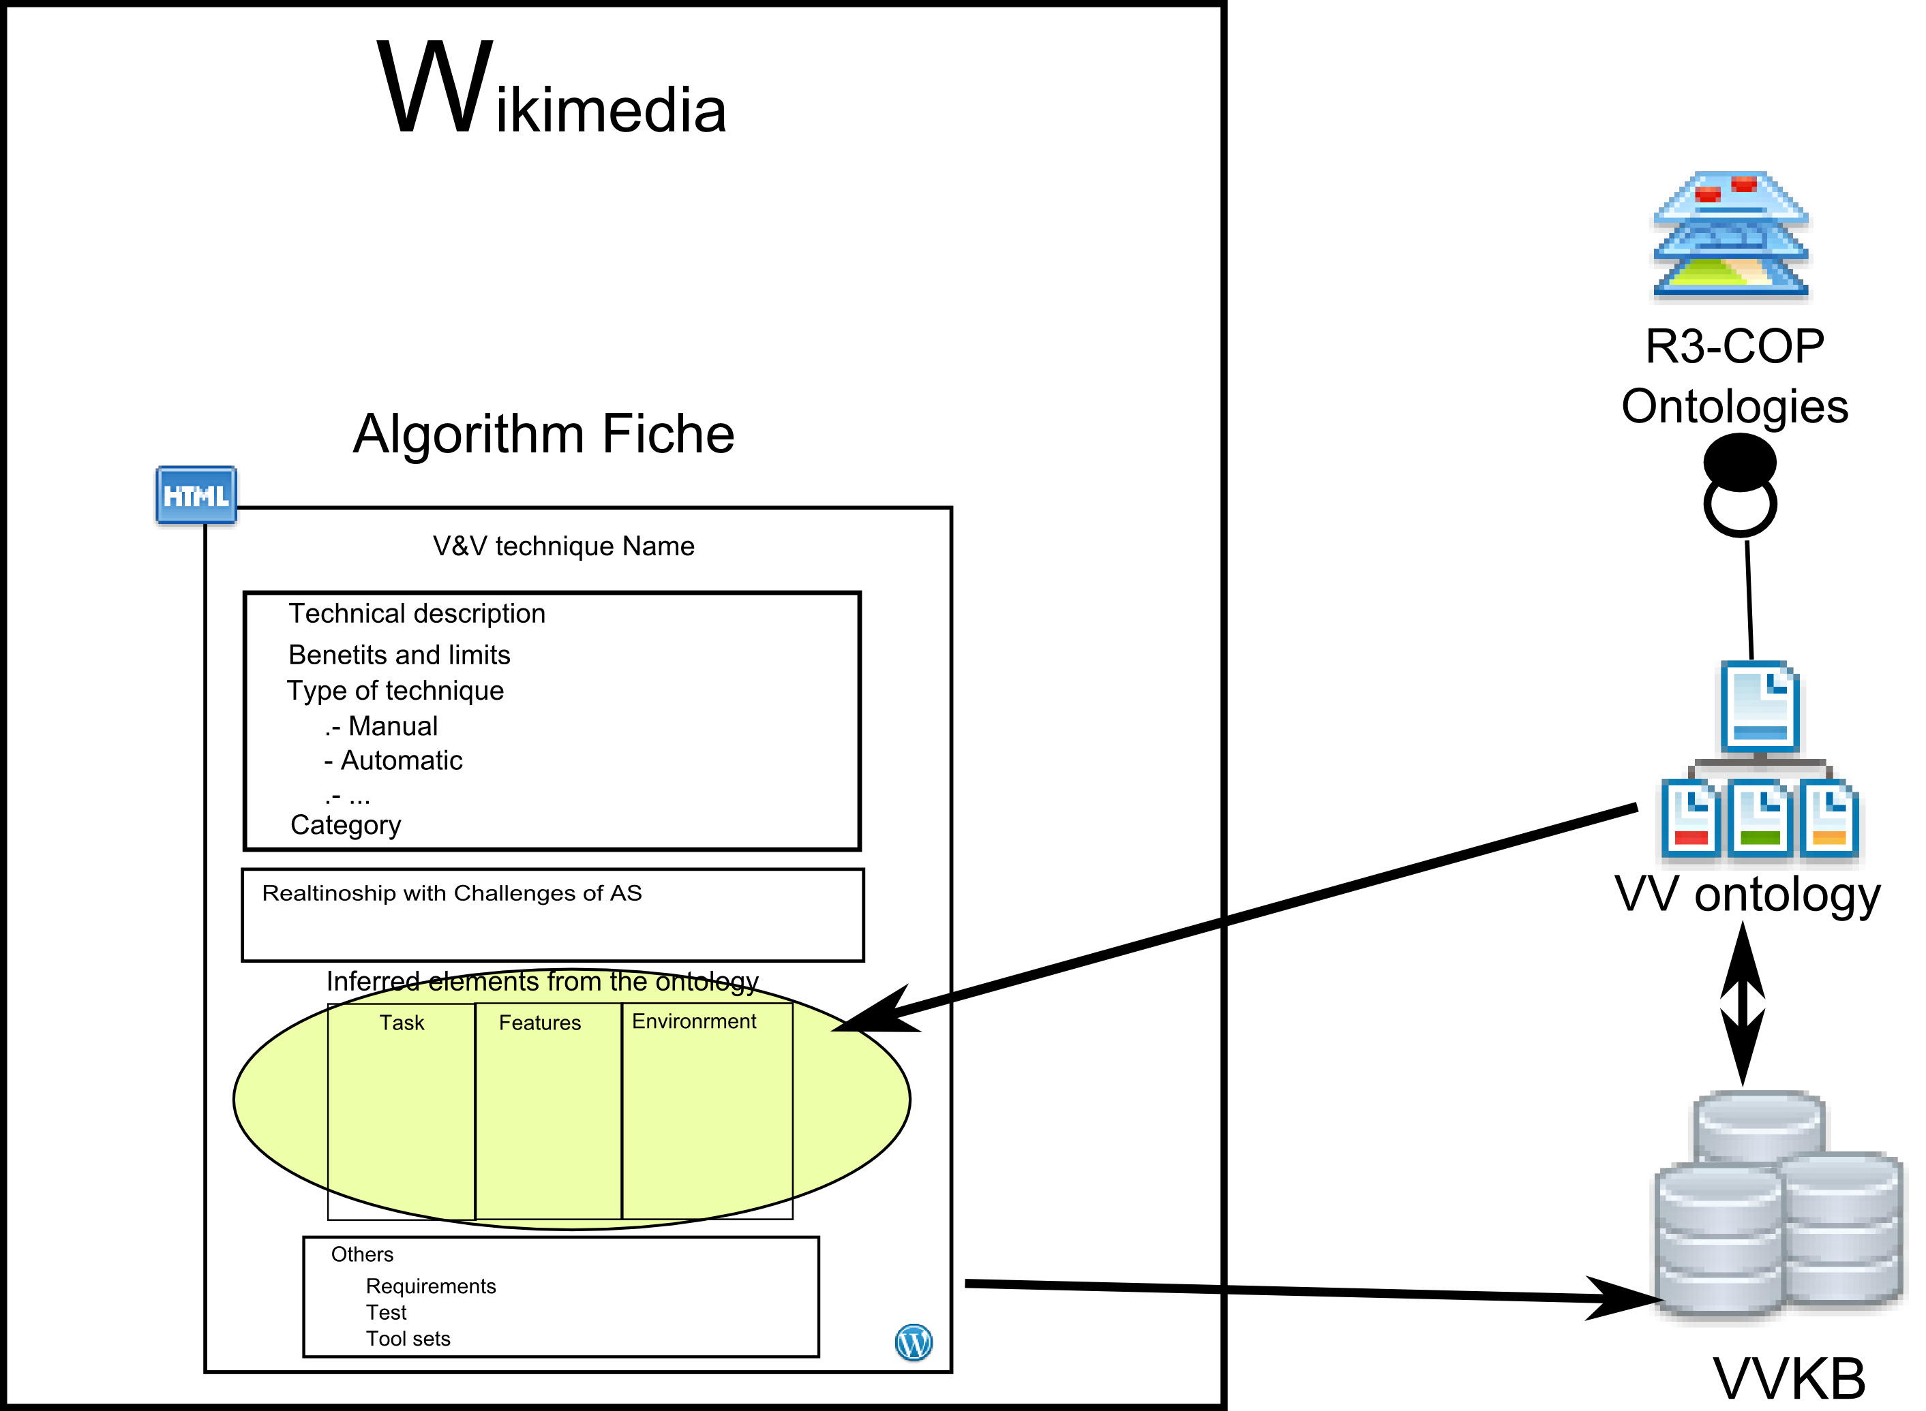
Fig. 6: Relationship between wiki, ontology and the fields of the individual algorithm form
- Conclusions
Composability, re-use and interoperability are main targets for R3-COP to create robust, safe robotic autonomous systems from building blocks. A knowledge base for design & development as well as for validation & verification with ontology-based and human-readable (Wiki-) standardized descriptions for methods, tools and components are key to this approach. Developing new test strategies for moving and adaptive (co-operating) systems with complex sensor input (e.g. stereo vision) and autonomous behavior, with measurable coverage, based on in-depth domain analysis, is one of the innovative contributions, which may be added together with the Knowledge Base concept to the ARTEMIS CRTP (Common Reference Technology Platform) to address these issues most relevant not only for cognitive robotic systems, which have not been addressed systematically until now, but also to critical systems engineering in general.

The ARTEMIS CRTP is aimed at by a cluster of ARTEMIS projects in the safety & high reliability area (e.g. CESAR, MBAT, SafeCer, iFEST, see references). Therefore, in the last phase of R3-COP, where the robotic RTP is addressed, closer information- and experience exchange with the other High-Rel Cluster projects is planned

Acknowledgements. The work is partially funded by the EC (ARTEMIS Joint Undertaking) and the partners’ national funding authorities under grant agreement 100233 (R3-COP project).
References
- ARTEMIS Joint Undertaking, the public private partnership for R&D in embedded systems, http://www.artemis-ju.eu/ .
- Related ARTEMIS-projects of the Safety/High-reliability cluster of projects:
  - R3-COP project “Resilient Reasoning Robotic Co-operating Systems”, (http://www.r3-cop.eu)
  - CESAR project “Cost-efficient methods and processes for safety relevant
embedded systems”, (http://www.cesarproject.eu)
  - MBAT project “Combined Model-based Analysis and Testing of Embedded Systems” (http://www.mbat-artemis.eu)
  - pSafeCer/nSafeCer projects “Safety Certification of Software-intensive Systems with Reusable Components;”, (http://www.safecer.eu )
  - iFEST project “industrial Framework for Embedded Systems Tools“ (http://www.artemis-ifest.eu )
- Alessandro Benini, Adriano Mancini, Riccardo Minutolo, Sauro Longhi, and Mauro Montanari. A modular framework for fast prototyping of cooperative unmanned aerial vehicles. Journal of Intelligent & Robotic Systems, 65:507–520, 2012. 10.1007/s10846-011-9577-1.
- L. Dalgaard, “Rational System-level Design Methodology for Autonomous Robotic Systems”, Ph.D. Thesis. Odense, 2011.
- R. Lill, F. Saglietti, „Model-based Testing of Autonomous Systems based on Coloured Petri Nets”, in Proc. Workshops ARCS 2012, Lecture Notes in Informatics, Vol. P-200, 28.2.2012, GI, TU Munich.
- Z. Micskei, Z Szatmári, J. Oláh, and I. Majzik, “A Concept for Testing Robustness and Safety of the Context-Aware Behaviour of Autonomous Systems”, in: Proc. of the 1st Int. Workshop on Trustworthy Multi-Agent Systems (TruMAS). KES-AMSTA 2012 Dubrovnik, Croatia, 25-27 June 2012.
- F. Saglietti, S. Söhnlein, R. Lill, “Evolution of Verification Techniques by Increasing Autonomy of Cooperating Agents”, in Autonomous Systems: Developments and Trends, Studies in Computational Intelligence, Vol. 391/2012, Springer.
- Z. Szatmári, J. Oláh and I. Majzik, “Ontology-based Test Data Generation using Metaheuristics”, in: Proc. of the 8th International Conference on Informatics in Control, Automation and Robotics (ICINCO 2011), July 28-31, 2011.

