Resistant Gates for Polymorphic Electronics

Radek Tesar, Richard Ruzicka and Vaclav Simek
Brno University of Technology
Faculty of Information Technology
Bozetechova 2, Brno, Czech Republic
{itesar, ruzicka, simekv}@fit.vutbr.cz

Abstract— The field of electronics is exposed to emergence of advanced materials with semiconducting properties as a perspective replacement for conventional silicon technology. These materials may comprise, for example, organic semiconductors. Number of interesting properties, such as ambipolarity, are usually observed. It's possible to imagine a transistor which can work under certain conditions in a P-channel mode whereas it achieves N-channel mode of conductivity in a different situation. This particular type of transistor with ambipolar behavior turns out to be useful for development of polymorphic electronics. Its notion tends to simplify design procedure of complex digital circuits and it may also bring an additional features for a given application scenario. In fact, this is helpful especially in those situations when it's necessary to change the target environment where the device with polymorphic circuit blocks is required to be operating. For example, a solar power plant control circuit will have a different functions during the daylight period and at night. The important characteristics is that its physical structure still remains to be the same. Above all, the impact of ambipolar property coupled with adoption of the emerging materials opens up a new direction for physical realization of the polymorphic building blocks.
Keywords-logic gates; polymorphic electronics; ambipolarity; organic semiconductors

Introduction
Polymorphism works in the following way: a circuit which is implementing the desired function f1 in a normal operating mode instantly reconfigures itself and activates the function f2, providing the target environment is subject to the occurrence of specific variations during the course of time (e.g. due to state of emergency, power failure, etc). Such behavior has been thoroughly discussed in [1], [2]. If the physical elements adhering to the suggested scheme aren’t available, another immediate option would be to perform their simulation by means of exploiting microprocessors or FPGA devices alike. However, there are some other negative characteristics (e.g. the need to use a larger number of logic gates and, thus, causing greater consumption within such a system, relatively slow reconfiguration process, program errors possibility, etc). Obviously, the polymorphic circuits should avoid these negative qualities. They should be easily and quickly reconfigurable (clear and quick response to the actual stimulus). In general, the same circuit structure layout should be used in case of polymorphic circuits performing different, in practice usually two, intended functions. On the contrary the conventional technologies would have to come up with two different physical circuits and switch between them with respect to a given situation. Polymorphic circuits are also virtually free from any program errors, because these circuits are not programmed (their function is determined by mutual interconnections of the individual building elements on a hardware level; in a similar way to the conventional low-level CMOS design), in contrast to microprocessors or FPGAs devices with programmable logic.
Most existing contemporary examples of polymorphic circuits are based on MOS (Metal Oxide Semiconductor) [1], or CMOS technology [3]. However, the conventional field-proven silicon technology, which is used in this case, doesn’t turn out to be the most convenient approach. In order to obtain a polymorphous operational characteristics in silicon technology, it is necessary to use various design tricks on a silicon level (such as different sizes of the transistors inside a chip). This technique is ultimately leading not only to the unusual properties introduced to the silicon elements, but it also causes a deterioration of the other device parameters (higher power consumption, lower cut off frequency, etc.). Already mentioned organic materials do not suffer with the suggested problems. In fact, these materials naturally exhibit desired polymorphic properties, as will be explained later. In addition, elements based on the organic materials [12] can be used in a previously unimaginable way. An example of this approach could be easily recognized in case of organic transistors and logic circuits fabricated by means of inkjet printing [4], [5], [10]. This opens up a wide field of application for such circuits – for example, in wearable electronics, rapid circuit prototyping, foldable display devices, low-cost sensing application or even enables the utilization of printed electronic circuits on a sheet of paper, which then becomes a part of newspapers, books, and other printed materials.
When we want to start using polymorphic circuits, it is necessary to first implement basic logic functions (gates), which will be subsequently combined with the aim to form larger logical elements. Therefore main attention will be given to the proposal of polymorphic logic gates whose functionality can be modified without additional dedicated signal. These gates will respond to a common stimulus (change in supply voltage level, temperature gradient and polarity of the supply voltage), which is distributed in its own essence throughout the circuit at no additional cost. Of course, polymorphic elements using auxiliary signal for a change of the function also exist. This dedicated signal is typically attached to the auxiliary gate of ambipolar transistors that make up the polymorphic element. This type of polymorphic elements, however, are not taken into account here.
As stated above, main attention in this contribution will be given to the polymorphic elements where the operational characteristics strongly depend on the polarity of attached supply voltage. Polymorphic electronics have to be typically devised from both multifunctional polymorphic and also conventional gates. Some polymorphic gates that work according to this principle were reported in [6]. To our best knowledge, none of these conventional gates are known to exhibit stable resistance to polarity change of supply voltage. Since no circuit is composed exclusively from polymorphic gates, it is also necessary to design the resistant gates as well, i.e. those immune to the changes in polarity of the supply voltage. Furthermore, such type of logic gates would have to keep their functionality in any polarity orientation. Standard logic gates cannot accept reverse polarity without danger of being permanently damaged; in addition, when the polarity is reversed the gates will simply cease to operate. Therefore, each gate would need to have its own Graetz bridge element integrated within the power supply circuitry. This would obviously mitigate the problem when changing the power supply polarity presented to the gate. However, the main disadvantage in this case can be seen in a possible growth of circuit complexity. However, the goal is to add more features while maintaining the circuit complexity at an acceptable scale or even help to reduce it

Conception of Ambipolar Transistor
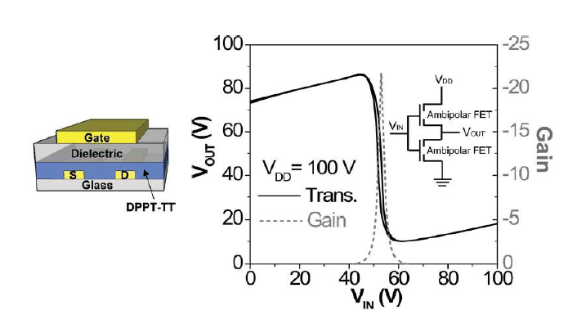
The fabrication of ambipolar transistors (acting as either P – type or N – type according to a given circumstances) has been already reported in a number of contemporary research publications. These are usually designed as unipolar devices, and often contains an organic semiconductor compound – typically a carbon nanotubes or similar nanomaterials.
- Stucture of ambipolar transistor (left), typical step response and gain of ambipolar inverter formed by two identical transistors.
Figure 1 above shows (in its left part) a cross section view of ambipolar transistor composition, which is formed from several various layers including diketopyrrolopyrroles-Thieno[3,2-b]thiophene copolymer [7]. It is a donor-acceptor (DA) copolymer which is based on diketopyrrolopyrrole (DPP). From a technical point of view, the key element within the structure of this transistor involves DA copolymer DPPT-TT (formerly called PDBT-co-TT). On the right side of Figure 1 there is shown a typical step response and gain of the ambipolar inverter made up by means of combining two of such transistors. Thanks to the ambipolar property, one transistor acts as a P-type transistor and the second N-type, although they are identical transistors. This feature can then be subsequently exploited for the space-efficient construction of polymorphic gates and even more complex circuits.
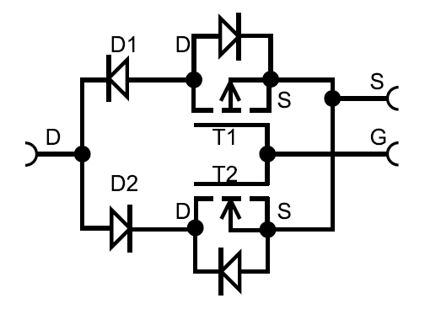

- Basic model of an ambipolar transistor.

Ambipolar Transistor Model
This section is dealing with a definition of fundamental model for ambipolar transistors and silicon diodes, which are important means for describing operation of polymorphic gates. Figure 2 shows an example of ambipolar transistor model created by means of utilizing conventional silicon MOSFET transistors. For the construction of such a model, transistors with terminated substrate would be preferable. Unfortunately, such transistors are rare, so the model was created from the standard P – type and N – type transistors. Each instance of the unipolar MOSFET transistor has an integrated body diode where its unwanted influence must be eliminated by anti – serial connection of diodes D1 and D2.
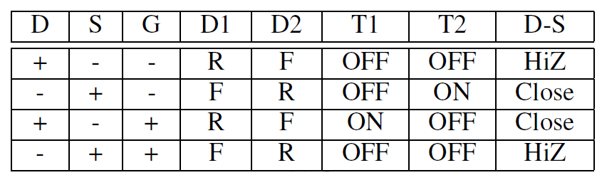
- Definition of Possible Operating States of an Ambipolar Transistor Model

The function of this model is explained in details within Table I above. Its columns D, S, G denotes the individual terminals of the transistor model; their values are + or -, which corresponds to the supply voltage polarity (Vcc, GND). Then, columns D1, D2 simply denote anti-serial diodes from transistor model and have values of F (forward direction) or R (reverse direction). Columns T1 and T2 are related to transistors from the same model. If a value is ON, the transistor is closed (current flows through the transistor), while OFF signature denotes that transistor is open (and therefore current cannot flow across this element). The last column depicts the behavior of the model where HiZ represents the high impedance state (model is “tri-stated”). “Close” option simply means that the model is closed and the conductive pat his available for current.

Semiconductor Diode Model
The semiconductor diode is a dipole, which uses the properties of PN junction (an interface between the P-type and the N-type semiconductors. PN junction acts as a gate, i.e. it transmits electric current in only one direction. PN junction can be connected in a reverse or forward direction, thus conducting the current just in one direction, like the aforementioned gate [8], pages 90 - 93.
Both parts of the crystal lattice diodes are contiguous; however, due to the electrostatic field of the tightly bound ion acceptor and donor near PN junction, there appears a void which acts as an insulating layer separating each part of P from N. The empty area between the semiconductor P and N can also be seen as a plate capacitor of plate area which is equal to a surface of PN junction and the width of the empty area. This capacitor has a so-called barrier capacity which is an important property of the diode, as it causes conduction of electrical current in the reverse direction at high signal frequencies. The corresponding capacity is large enough, and its size depends on junction surface and reaches values from several picofarads to several tens of nanofarad [8], page 95.
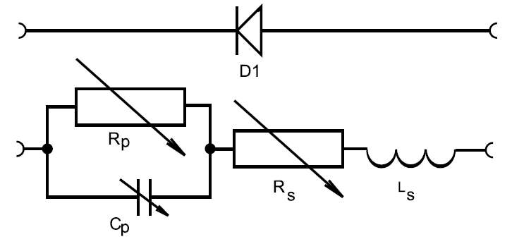
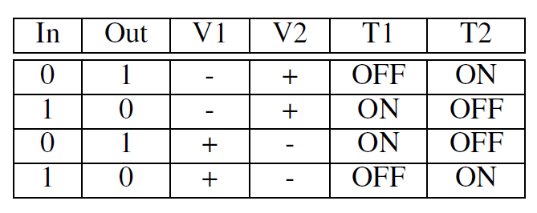
- Semiconductor diode model.
The top of Figure 3 shows the schematic symbol of a standard semiconductor diode and the bottom part illustrates the equivalent circuit of the diode [8], page 96. Circuit Rp, Cp replaces the usual PN junction diodes and is accompanied by a resistance Rs (represents the resistance of the rest of the semiconductor material and the remaining leads). Ls is an inductance of the coil leads diodes. It is valid at a very high frequencies only.
The level of depletion can change by the anode voltage, thus changing the capacity of the junction. It also changes the resistance Rp of the depletion. When the anode voltage in the reverse direction increases, the thickness of the depletion also increases. Therefore, the capacity Cp of the junction decreases and resistance Rp of the junction increases.

Ambipolar inverter
For our experiments we consider so called positive logic; this means that a logic 0 will correspond ot a voltage level near GND (or zero volts) and logic 1 is going to attain the voltage level close to Vcc (supply voltage). The suggested assumption is strictly respected throughout the remaining sections of the contribution.
The simplest gate formed from an organic ambipolar transistors is an inverter. Its schematic diagram is depicted on Figure 1 within section II. Of course, when we consider conventional inverter formed by silicon transistors, the top transistor is normally the P-type and bottom is N-type. But when the ambipolar transistors are used, both are of the same type. It means that the transistors will autonomously select their operating mode with respect to their deployment inside a given circuit. This makes the ambipolar inverter resistant to power supply polarity change – if the Vcc and GND are swapped, the type of transistors will change accordingly (N to P and vice versa). Table II below (within its right portion) lists all possible or valid states of the ambipolar inverter, thus demonstrating how it works. This principle is then used in polymorphic NAND and NOR gates, as described, for example, in [6]. These gates will therefore reconfigure their logic function by changing the polarity of supply voltage.
The aim in this perspective is to develop and validate an easily applicable system of polymorphic gates that will behave as described above, and will have the potential to be exploited for construction of nearly any type of logic circuits. For this purpose we need to create a comprehensive system of logical functions – NAND or NOR (polymorphic gates with both functions are already created, see [6]).
- Inverter States Overview

As mentioned before, no circuit is composed solely of polymorphic gates. Due to this fact it is also necessary to design the resistant gates, i.e., those not responding to the change in polarity of the supply voltage in our case. These would then keep their functionality in any polarity.
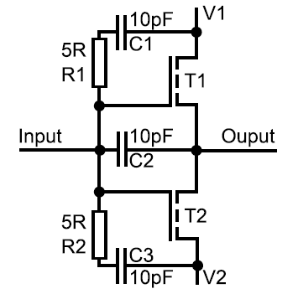

- Ambipolar inverter equivalent circuit.
It is obviously possible to use the properties of ambipolar transistors for a construction of so called resistant logic gates and similar circuit elements (for clarification see Figure 1). Between the gate and electrodes (Drain, Source) there is inserted a dielectric layer, which is leading to formation of a capacitor between such gate and electrodes. Figure 4 above illustrates the ambipolar inverter replacement scheme, where the gate is replaced by set of capacitors, as explained above. Now assume that V1 is Vcc and V2 is GND. If GND is connected to the input of the inverter, upper capacitor (C1) will be charged, while the bottom one (C3) remains flat. By means of connecting Vcc to this input means that the lower capacitor (C3) gets charged and the upper one (C1) discharged. Which capacitor is charged then determines which transistor will be open (in the first case upper transistor, in second case lower one) and thus obtain the corresponding output voltage. Circuit current can only flow when the capacitors are charging; after that capacitor is charged, the consumption of the inverter is zero. It is of course valid under the ideal conditions and when only one of the transistors is open.
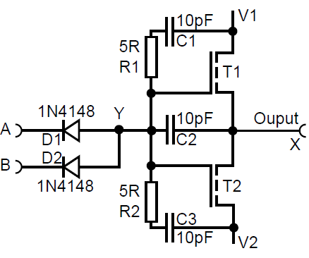

- Resistant NAND gate basic formation.

Resistant NAND Gate
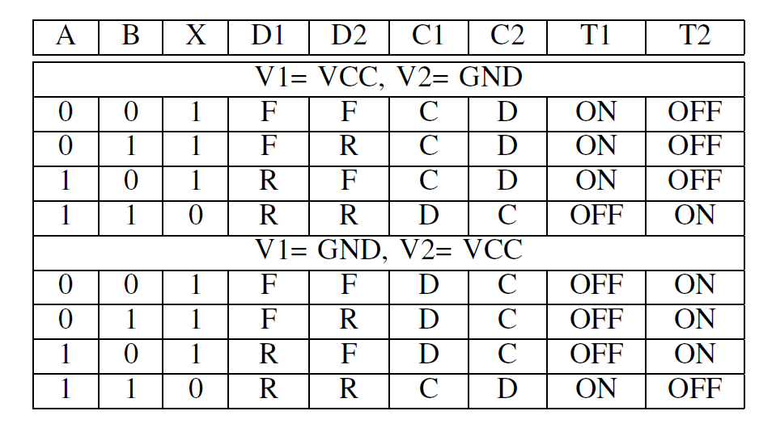
In Figure 5 above there is shown a resistant NAND gate made up from ambipolar transistors. In order to form the NAND gate, a diode logic is used to create an AND logic function and the result is then inverted by ambipolar inverter. This inverter has also an essential function in this circuit as will be explained later, so it is not possible to omit it and create simple AND gate in such way.
- Overview of Resistant NAND Gate States
In Figure 5 above, the dominant logic value is zero on inputs A and B, so whenever the logic 0 is applied on either of these inputs, C1 is subsequently charged, and transistor T1 will be opened. Furthermore, the output produce logic 1. Expected V1 is Vcc level whereas V2 is GND in this case. If the inputs A and B in Figure 5 are logic 1 level, the diode is connected in a reverse direction and the current cannot flow thru, but some current flows until barrier capacitor is charged (this property was stated in section Semiconductor diode model). If either input A or B (or both) are connected as logical 0, current flows through diodes, which charges a capacitor C1 or C3 (according to the polarity of the supply voltage) and thus opens the corresponding transistor. The output is then always logical 1, regardless of how the power supply is polarized. The situation is shown in Table III. The meaning of each column is the same as in Table I. Moreover, there are several columns with value C filled in – capacitor is charged (practically capacitor charging takes some time, but it can be ignored here), or D – capacitor is discharged (discharge also takes some time, which we neglect).

Resistant NOR Gate
Figure 6 below illustrates the composition of a resistant NOR gate utilizing just two ambipolar transistors. As well as in the previous case, for NOR logic element the solution using the embedding of diode is chosen. The output stage is finally made of the inverter in order to derive the proper logic level corresponding to NOR behavior.
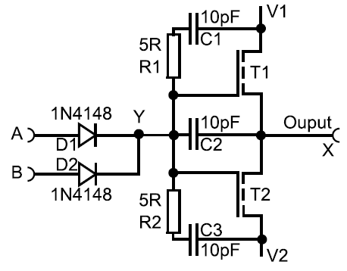

- Resistant NOR gate basic circuit diagram.
If both inputs A and B in Figure 6 gain the same logical value of 0, diodes are then connected in a reverse direction and current cannot flow through. Of course, minute volume of current continues to flow until the barrier capacitor is charged (as stated in Section IV). If either input A or B (or both) are connect to logical 1, the respective diode still conducts current, causing the charging of capacitors C1 or C3 and to open the corresponding transistor. The output will then produce logical 0. As it can be obviously recognized, the dominant logical level in NOR gate is 1.

Simulation of Ambipolar Logic Gate
Transistor-level structure of the polymorphic ambipolar OFET gate with NAND/NOT function was presented in Section II. Due to the actual lack of physical ambipolar devices an alternative model in PSpise environment was defined and closely evaluated (see Figure 7 and 8 below), using CMOS FET transistors with separate substrate connection. Physical interconnection structure of the gate is proposed with the ambipolar behavior in mind because the transition between NAND/NOR function doesn’t involve any additional changes. Just the reversal of V_{dd} polarity is enough to trigger the mode change. Due to this fact, it was possible to obtain very accurate simulation of the expected ambipolar behavior even without real ambipolar transistors at hand.
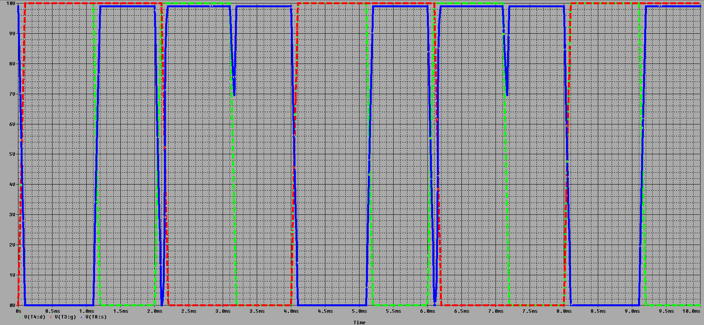
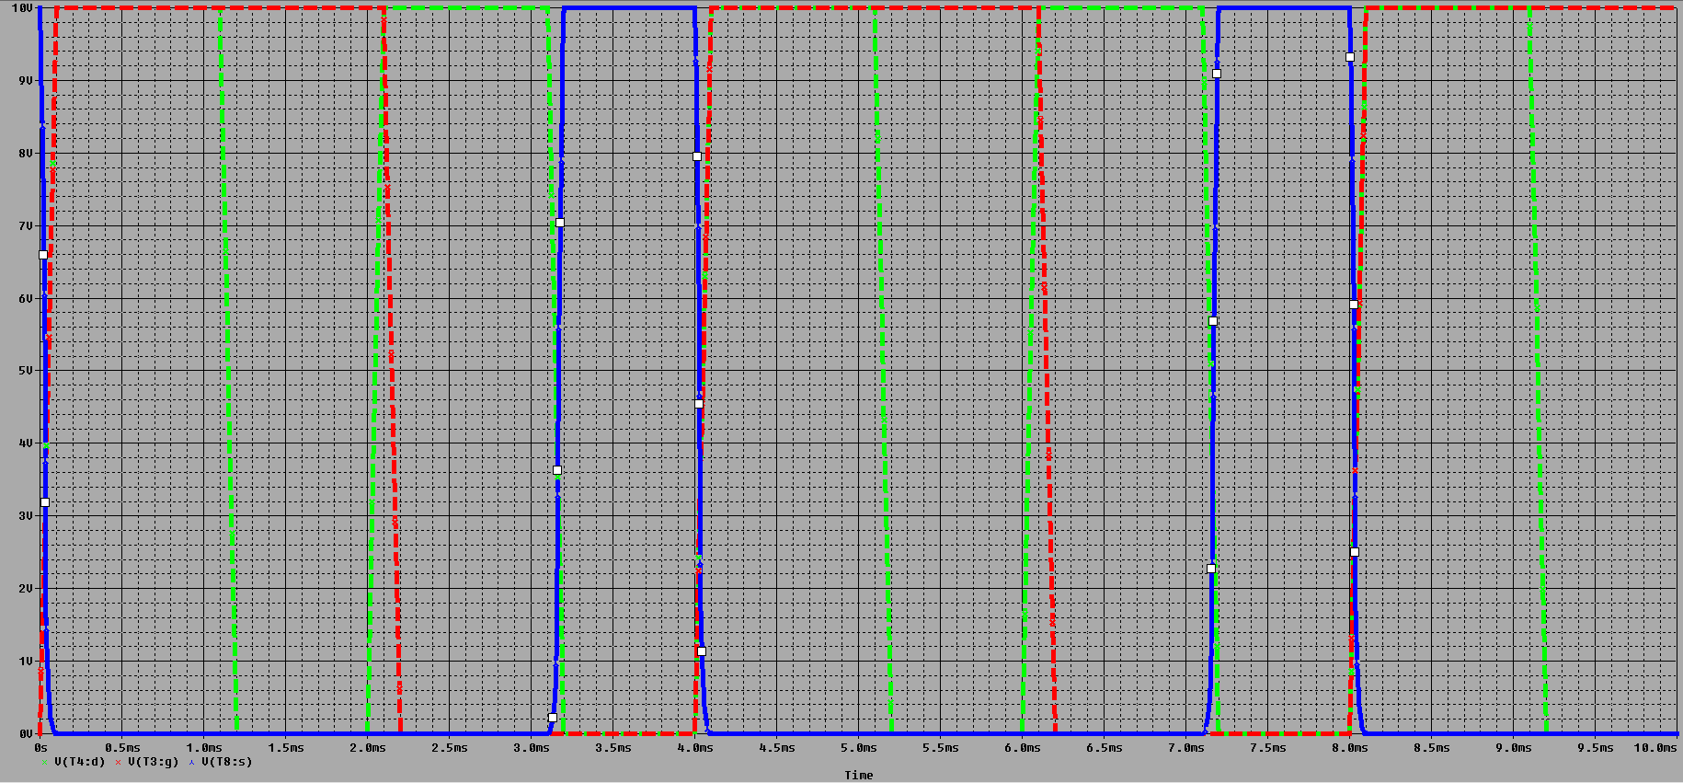
- The signal waveforms obtained during the evaluation of NAND mode in PSpice simulation environent. Inputs to the gate are drawn in red and green color respectively, while the output value is shown in blue color.
- The signal waveforms obtained during the evaluation of NOR mode in PSpice simulation environent. Inputs to the gate are drawn in red and green color respectively, while the output value is shown in blue color.

Conclusion
This paper introduced the basic resistant gates, which are essential for the design of polymorphic circuits built upon the fundamental circuit components with the ambipolar property. Considerable attention was already given to the notion of polymorphic gates fabricated with the conventional CMOS technology of its minor adjustments in a number of literature resources. But it’s also vital to take into account the emerging materials and technologies as these evidently tends to mitigate some of the suggested drawback of sticking to the conventional, yet field-proven, fabrication methods. In fact, especially those materials with, for example, inherent ambipolar property may have a significant contribution towards more efficient and reliable design process of various meaningful polymorphic circuit components. Resistant gates introduced here are designed in the way that their topology and electrical properties permit to create them from the same organic materials as other components in such circuits. This is essential for the design of printed electronics, and also facilitates a process of the design flow. Further work will be devoted to the development of additional gates needed to design superior or more extensive polymorphic circuits. For example, reconfigurable transistors taking into account the recent advancements within the field of nanotechnology, like silicon nanowires, integration of graphene layers [11] or carbon nanotubes [9] with semiconducting properties are expected to play a pivotal role in pushing forward the trends connected to the multifunctional or polymorphic electronics world.

Acknowledgment
This work was supported by the IT4Innovations Centre of Excellence (no. CZ.1.05/1.1.00/02.0070) and by the national COST grant Unconventional Design Techniques for Intrinsic Reconfiguration of Digital Circuits: From Materials to Implementation (no. LD14055).

References
- Polymorphic electronics, Stoica Adrian, Zebulum Ricardo, Keymeulen Didier. Evolvable Systems: From Biology to Hardware, 2001, pages: 291 – 302, Springer Berlin Heidelberg, ISBN: 978-3-540-42671-4 (Print), 978-3-540-45443-4 (Online).
- Taking evolutionary circuit design from experimentation to implementation: some useful techniques and a silicon demonstration, Stoica Adrian, Zebulum RS, Guo Xin, Keymeulen Didier, Ferguson MI, Duong Vu, 2004, IEE Proceedings-Computers and Digital Techniques vol. 151(4), pp. 295-300, DOI: 10.1049/ip-cdt:20040503.
- REPOMO32 - New reconfigurable polymorphic integrated circuit for adaptive hardware, Sekanina, L.; Ruzicka, R.; Vasicek, Z.; Prokop, R.; Fujcik, L., Evolvable and Adaptive Hardware, 2009. WEAH ’09. IEEE Workshop on, vol., no., pages 39 – 46, April 30 2009 – March 2 2009, DOI: 10.1109/WEAH.2009.4925666.
- Inkjet-printing-based soft-etching technique for high-speed polymer ambipolar integrated circuits Dongyoon Khim at al, Dongguk University, Seoul, Republic of Korea, ACS Applied materials & interfaces, 2013.
- High-Performance Printed Carbon Nanotube Thin-Film Transistors Array Fabricated by a Nonlithography Technique Using Hafnium Oxide Passivation Layer and Mask Sueres Kumar Raman Pillai and Marry B. Chan-Park, Nanyang Technological University, Singapore, ACS Applied materials & interfaces, 2012.
- Polymeric Polymorphic Electronics: Towards Multifunctional Logic Elements Based on Organic Semiconductor MaterialsRika, R., imek, V., Proceedings of CSE 2012 International Scientific Conference on Computer Science and Engineerig, Koice, SK, FEI TU v Koiciach, 2012, pages 154 – 161, ISBN 978-80-8143-049-7.
- High-Performance Ambipolar Diketopyrrolopyrrole-Thieno[3,2-b]thiophene Copolymer Field-Effect Transistors with Balanced Hole and Electron Mobilities, Zhuoying Chen, Mi Jung Lee, Raja Shahid Ashraf, Yun Gu, Sebastian Albert-Seifried, Martin Meedom Nielsen, Bob Schroeder, Thomas D. Anthopoulos, Martin Heeney, Iain McCulloch, and Henning Sirringhaus. Advanced Materials 2012, 24, pages 647 - 652. DOI: 10. 1002/adma.201102786.
- Elektronika Ing. Jan Matatko, SNTL 1987, 272 pages, ISBN 8003000386.
- Yu, W. J., Kim, U. J., Kang, B. R., Lee, I. H., Lee, E. H., Lee, Y. H.: Multifunctional logic circuit using ambipolar carbon nanotube transistor. Proc. SPIE 7399, 739906 (2009).
- Kawase, T., Shimoda, T., Newsome, C., Sirringhaus, H., Friend, R. H.: Inkjet Printing of Polymer Thin Film Transistors. J. of Thin Solid Films 438 (2003), Elsevier, pp. 279-287.
- Tanachutiwat, S., Lee, J. U., Wang, W., Sung, C. Y.: Reconfigurable multi-function logic based on graphene P-N junctions, In: Proc. of 47th ACM/IEEE Design Automation Conference, Anaheim, CA, IEEE CS, 2010, pp. 883 – 888, ISBN 978-1-4244-6677-1.
- Paasch, G., Lindner, Th., Rost-Bietsch, C.: Operation and Properties of Ambipolar Organic Field-effect Transistors, In: Journal of Applied Physics, Vol. 98, No. 8, 2005, US, pp. 084505-1 - 084505-13, ISSN 0021-8979, DOI 10.1063/1.2085314.

