DOI: 10.1002/cbic.201((will be completed by the editorial staff))
Maximizing the Efficiency of Multi-enzyme Process by Stoichiometry Optimization
Pavel Dvorak^{[a,b]}, Nagendra P. Kurumbang^{[a]}, Jaroslav Bendl^{[a,b,c]}, Jan Brezovsky^{[a]}, Zbynek Prokop^{[a,b]}, and Jiri Damborsky*^{[a,b]}
[a] P. Dvorak, Dr. N. P. Kurumbang, J. Bendl, Dr. J. Brezovsky, Dr. Z. Prokop, Prof. J. Damborsky
Loschmidt Laboratories, Department of Experimental Biology and Research Centre for Toxic Compounds in the Environment Faculty of Science, Masaryk University Kamenice 5/A13, 625 00 Brno, Czech Republic
E-mail: jiri@chemi.muni.cz
[b] P. Dvorak, J. Bendl, Dr. Z. Prokop, Prof. J. Damborsky International Clinical Research Center, St. Anne's University Hospital Brno Pekarska 53, 656 91 Brno, Czech Republic
[c] J. Bendl
Department of Information Systems Faculty of Information Technology, Brno University of Technology, Bozetechova 1, 612 00 Brno, Czech Republic
Supporting information for this article is available on the WWW under http://dx.doi.org/10.1002/cbic.20xxxxxxx.
Dedication ((optional))

Abstract: Multi-enzyme processes represent an important area of biocatalysis. Their efficiency can be enhanced by optimization of biocatalysts’ stoichiometry. Here we present a workflow for maximizing the efficiency of a three-enzyme system catalysing a five-step chemical conversion. Kinetic models of pathways featuring either wild-type or engineered enzymes were built and the enzyme stoichiometry of each pathway was optimized. Mathematical modelling and one-pot multi-enzyme laboratory experiments provided detailed insights into pathway dynamics, enabled the selection of suitable engineered enzyme and afforded high efficiency while minimizing biocatalyst loadings. The optimizing of stoichiometry in a pathway with engineered enzyme reduced the total biocatalyst load by an impressive 56 %. Our new workflow represents a broadly applicable strategy for optimizing multi-enzyme processes.
In vitro multi-enzyme processes have great potential for the biosynthesis of fine and bulk chemicals, bioremediation and biosensing.^{[1]} Studies on two-enzyme systems dominate the literature, but systems of three^{[2]}, four^{[3]} and even twelve^{[4]} or thirteen^{[5]} enzymes are known. Multi-enzyme systems are superior to single-enzyme biocatalysis in that they can catalyze more complex synthetic schemes. In vitro multi-enzyme networks enable simpler process control than analogous in vivo systems and suffer less from reactant toxicity.^{[6]} However, both system types often exhibit reaction bottlenecks due to imbalanced enzyme properties.
Protein engineering is often used to improve enzymes’ catalytic properties and stability.^{[7]} Many engineered enzymes can be used in multi-enzyme processes but methods for predicting their impact on productivity are lacking. Kinetic modelling is essential for analyzing enzymatic reactions and can enable their rational optimization.^{[1c,8]} However, there are only few accurate kinetic models of in vitro multi-enzyme systems.^{[2,3,5,9]} Available models rarely have experimental support and their use in optimizing processes with engineered enzymes has not been adequately explored.
The aim of this study was to develop a workflow for optimizing multi-enzyme processes by using kinetic modelling to predict the effects of varying enzyme stoichiometry and introducing available engineered enzymes. Our model system (Scheme 1) was a synthetic metabolic pathway for the five-step biotransformation of toxic industrial waste product 1,2,3-trichloropropane (TCP) into the commodity chemical glycerol (GLY).^{[10]} This pathway has been previously assembled inside living cells^{[11]} and is based on haloalkane dehalogenase DhaA from Rhodococcus rhodochroust NCIMB 13064^{[12]}, haloalcohol dehalogenase HheC,^{[13]} and epoxide hydrolase EchA from Agrobacterium radiobacter AD1.^{[14]} Three different haloalkane dehalogenase variants were evaluated: (i) wild-type DhaA; previously constructed mutants (ii) DhaA31 with improved activity;^{[15]} and (iii) DhaA90R with increased enantioselectivity.^{[16]} Kinetic models were built for pathways using each DhaA variant and their enzyme stoichiometry was optimized under defined constraints.
We initially prepared soluble enzymes with purities of ≥95 % for DhaA and EchA and ≥85 % for HheC (Supporting Information). To validate the one-pot multi-enzyme biotransformation of TCP into GLY, 1 mg each of purified DhaA, HheC and EchA were mixed in 10 ml of Tris-SO₄ buffer (pH 8.5) and incubated with 2 mM TCP at 37 °C for 300 min. The enzymes’ molecular weights are similar (34.1, 29.3 and 36.5 kDa, respectively), so their mass ratio roughly equals their molar ratio. A gas chromatography (GC) method for detecting and quantifying TCP and all pathway intermediates in a single analysis was developed and used to monitor the five-step process (Methods and Figure S1, Supporting Information). The time course for the conversion confirmed the pathway’s viability and revealed two major bottlenecks: (i) the slow initial conversion of TCP to 2,3-dichloropropan-1-ol (DCP); and (ii) the mismatched selectivity of DhaA and HheC, which caused (S)-DCP to accumulate (Scheme 1 and Figure S2, Supporting Information). Similar bottlenecks were identified in vivo.^{[11]}

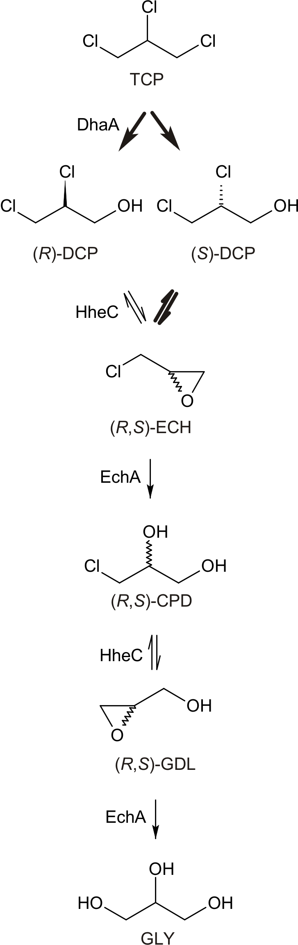

Scheme 1. Synthetic pathway for the three-enzyme biotransformation of 1,2,3-trichloropropane. Five consecutive steps are catalyzed by the haloalkane dehalogenase DhaA, from Rhodococcus rhodochrous NCIMB 13064; the haloalcohol dehalogenase HheC and the epoxide hydrolase EchA from Agrobacterium radiobacter AD1. 1,2,3-trichloropropane (TCP) is converted via (R)-2,3-dichloropropane-1-ol ((R)-DCP) and (S)-2,3-dichloropropane-1-ol ((S)-DCP), epichlorohydrin (ECH), 3-chloropropane-1,2-diol (CPD), glycidol (GDL) to glycerol (GLY). Key bottlenecks are indicated by bold arrows.

We then investigated two DhaA mutants with properties tuned to address these bottlenecks. The mutant DhaA31 was previously constructed in our laboratory using computer-aided focused directed evolution of protein tunnels.^{[15]} Its catalytic rate towards TCP is 32 times that of wild-type DhaA. The mutant DhaAr5-90R (henceforth “DhaA90R”) was obtained by van Leeuwen and co-workers via the focused directed evolution of DhaA31. It has the same activity as wild-type DhaA but 7 times higher selectivity for (R)-DCP formation.^{[16]} Time courses for the three-enzyme conversion of TCP using purified DhaA31 or DhaA90R were recorded under the conditions described for the wild-type pathway. The differences between the resulting conversion profiles were consistent with the kinetic properties of DhaA, DhaA31 and DhaA90R (Figure S2 and Tables S2-S4, Supporting Information).
Sixteen steady-state kinetic parameters were determined for each purified enzyme to establish a kinetic model of the pathway (Table 1 and Supporting Information). All of the studied reactions exhibit Michaelis-Menten kinetics. The conversion of glycidol (GDL) into GLY, was described by a Michaelis-Menten equation with two inhibition constants defining the inhibitory effects of GLY (K_{i} = 1.00 mM) and TCP (K_{c} = 0.21 mM) (Supporting Information). These effects together with the substrate preference of EchA for epichlorohydrin (ECH) caused GDL accumulation (Figure S2).

Table 1. Experimental steady-state kinetic parameters used in the kinetic model.
DhaA |  | HheC
K_{m,TCP} (mM) | 1.01±0.08 | K_{m,(R)-DCP} (mM) | 2.49±0.16
k_{cat,TCP,(R)-DCP} (s⁻¹) | 0.04^{[a]} | K_{m,(S)-DCP} (mM) | 3.33±0.51
k_{cat,TCP,(S)-DCP} (s⁻¹) | 0.03^{[a]} | K_{m,CPD} (mM) | 0.86±0.07
DhaA31 |  | k_{cat,(R)-DCP} (s⁻¹) | 1.81±0.05
K_{m,TCP} (mM) | 1.79±0.09 | k_{cat,(S)-DCP} (s⁻¹) | 0.08±0.00
k_{cat,TCP,(R)-DCP} (s⁻¹) | 0.58^{[b]} | k_{cat,CPD} (s⁻¹) | 2.38±0.06
k_{cat,TCP,(S)-DCP} (s⁻¹) | 0.47^{[b]} | EchA
DhaA90R |  | K_{m,ECH} (mM) | 0.09±0.08
K_{m,TCP} (mM) | 12.56±2.99 | K_{m,GDL} (mM) | 3.54±0.09
k_{cat,TCP,(R)-DCP} (s⁻¹) | 0.19^{[c]} | k_{cat,ECH} (s⁻¹) | 14.37±0.52
k_{cat,TCP,(S)-DCP} (s⁻¹) | 0.02^{[c]} | k_{cat,GDL} (s⁻¹) | 3.96±0.08
[a] Determined from the ratio of (R)- and (S)-DCP production as 56 % and 44 % of 0.07±0.00 s⁻¹ for k_{cat,TCP,(R)-DCP} and k_{cat,TCP,(S)-DCP}, respectively (Supporting Information, Methods). [b] Determined as 55 % and 45 % of 1.05±0.02 s⁻¹ for k_{cat,TCP,(R)-DCP} and k_{cat,TCP,(S)-DCP}, respectively. [c] Determined as 90 % and 10 % of 0.21±0.03 s⁻¹ for k_{cat,TCP,(R)-DCP} and k_{cat,TCP,(S)-DCP}, respectively.
The kinetic model was validated against experimental data for the three-enzyme conversion of 2 mM TCP (Figure S2). The two datasets were in good agreement – using 1:1:1 mixtures of the three enzymes with total enzyme loads of 3 mg, the predicted (and measured) productivities of the DhaA, DhaA31 and DhaA90R pathways were 72 % (62 %), 85 % (85 %) and 45 % (42 %), respectively. No enzyme inactivation occurred, but the model could be extended to include inactivation constants if necessary.
The model was then used to predict the DhaA, HheC and EchA loadings needed to achieve 95 % conversion of TCP to GLY under the chosen conditions by simulating stepwise increases in enzyme loading within the reaction system until the productivity goal was reached (Experimental Section and Supporting Information). At a fixed DhaA:HheC:EchA mass ratio of 1:1:1, the wild-type haloalkane dehalogenase pathway reached the productivity goal using 2.4 mg of each enzyme, i.e. a total enzyme load of 7.2 mg (Figure 1). The DhaA31 and DhaA90R pathways required 1.8 mg and 4 mg of each enzyme, respectively, (i.e. total enzyme loads of 5.4 or 12 mg) to reach the goal. The differences in the modelled time courses and quantities of enzyme required to achieve 95 % conversion for the three pathway variants demonstrate the profound effects of introducing engineered DhaA variants (Figure 1). Despite a pronounced accumulation of DCP and GDL during the initial 25 min, the DhaA31 pathway was around 25 % more efficient than the wild-type version. DhaA31 significantly accelerated the conversion of TCP and thus accelerated the consumption of accumulated GDL by suppressing TCP’s inhibitory effect. Conversely, DhaA90R reduced the system’s efficiency despite effectively minimizing DCP accumulation. This selective but catalytically inefficient mutant was thus not beneficial to the process.
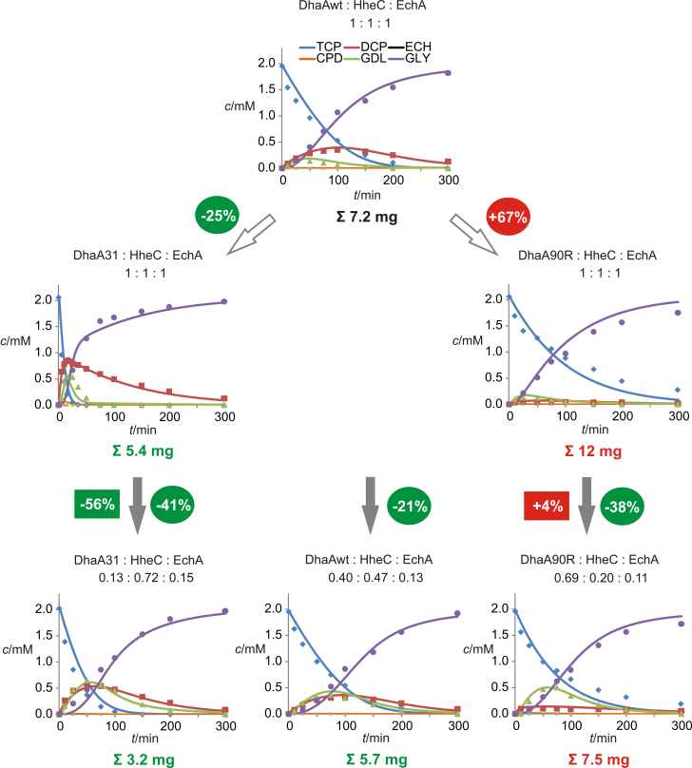
Figure 1. Optimization of three-enzyme conversion of 1,2,3-trichloropropane by kinetic modelling and employment of engineered enzyme variants. Calculated and measured results are indicated by solid lines and symbols, respectively. The following parameters were constrained: reaction volume (10 ml), initial TCP concentration (2 mM), and reaction duration (300 min). The initial optimization goal was 95 % conversion of TCP into GLY within 300 min using a 1:1:1 ratio of wild-type enzymes. The calculated and experimentally verified total enzyme loading required to achieve this is 7.2 mg. The wild-type DhaA enzyme was then replaced with the mutants DhaA31²³ or DhaA90R²⁴ to study the effect of their kinetics on the pathway (white arrows). Further optimization was achieved by tuning the enzyme ratios (grey arrows). Reductions in total enzyme loading achieved by employment of mutants or stoichiometry optimization alone and stoichiometry optimization together with mutants's effect are shown in circles and squares, respectively. Experimental concentrations of 1,2,3-trichloropropane (TCP), 2,3-dichloropropane-1-ol (DCP), epichlorohydrin (ECH), 3-chloropropane-1,2-diol (CPD), glycidol (GDL) and glycerol (GLY) were determined by GC and using a glycerol assay kit. Data points represent mean values from three independent experiments. Error bars are omitted for clarity; standard deviations are provided in the Supporting Information (Tables S2-S4).

We then evaluated the effects of enzyme stoichiometry on efficiency. An algorithm was used to minimize the total enzyme load without sacrificing productivity (Methods and Animation S1, Supporting Information). Optimal enzyme mass ratios were calculated for each pathway. The modelled time courses for individual reactions were similar in each case, but the optimized ratios and total enzyme loadings differed significantly between pathways (Figure 1). Enzyme stoichiometry optimization increased the efficiencies of the DhaA, DhaA31 and DhaA90R pathways and reduced their total enzyme loadings required for >95 % conversion by 21 %, 41 %, and 38 %, respectively.
All of the optimization simulations were validated by testing the enzyme mass ratios in vitro. The resulting data agreed very closely with the predictions (Figure 1). The optimized DhaA90R pathway was around 10 % less productive than predicted, possibly because the K_{m} of DhaA90R for TCP was underestimated due to the limited water solubility of TCP (cca. 10 mM). In all other cases, the optimized systems achieved productivities of 94 % - 98 % (Table S2-S4, Supporting
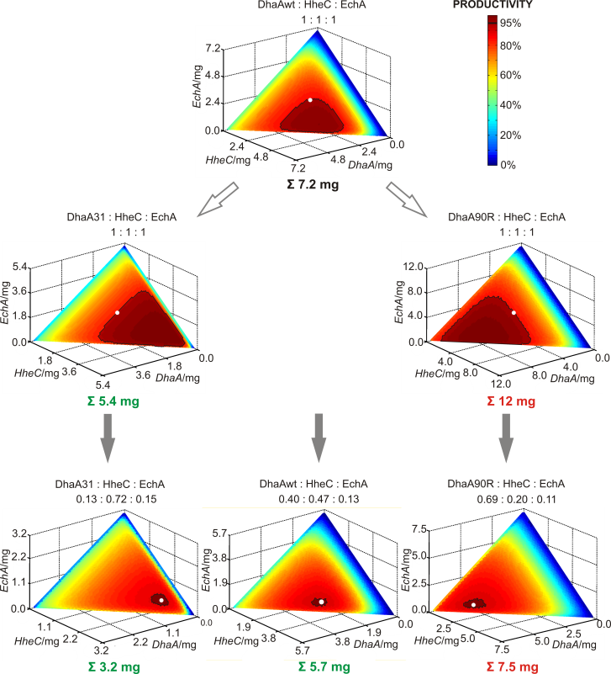
Figure 2. Isoproductivity color charts showing how biocatalyst concentration affects productivity in the three-enzyme conversion of 1,2,3-trichloropropane into glycerol. Applied constraints are described in the caption of Figure 1; the optimal solutions shown in that figure are indicated by white dots. Values on axes represent the loading of the corresponding enzyme in the reaction mixture. The black line indicates the threshold productivity of 95 %.

Information). Because the experimental time courses only reflect optimal cases based on pre-defined constraints, we used the simulated data to create 3D isoproductivity charts showing the effects of varying the loadings of the DhaA variants, HheC and EchA (Figure 2). These charts show the limiting components for each pathway and can be used to identify solutions with similar productivities.
Our results demonstrate that modifying enzyme kinetic parameters and optimizing enzyme stoichiometry both improved the efficiency of the studied multi-enzyme system. However, the far simpler process of stoichiometry optimization had a greater impact than introducing engineered enzymes. The optimized pathway using wild-type DhaA required a similar total enzyme load to the non-optimized pathway using the engineered DhaA31 (5.7 mg versus 5.4 mg), showing that kinetic modelling alone can provide excellent solutions in certain cases. Naturally, the best result was achieved with an optimized pathway using engineered DhaA31: additive effects in this case reduced the catalyst load required for 95 % productivity by 56 % relative to the unoptimized wild-type pathway (Figure 1). This would be very economically beneficial in a large-scale industrial process.
In summary, we present an experimentally validated in silico optimization of a multi-enzyme process by biocatalysts’ stoichiometry tuning. Our workflow entails: (i) experimental verification of process viability, (ii) determination of enzyme kinetics, (iii) identification of pathway bottlenecks and selection of suitable engineered enzymes, (iv) development of a robust and accurate kinetic model, (iv) experimental model validation, and (v) process optimization by in silico enzyme stoichiometry modelling. Recent progress in efficient enzyme stabilization^{[17]} and ex-vivo cofactor regeneration^{[18]} together with the development of integrated analytical techniques^{[19]}, increases in computational power, and the growing availability of kinetic data will enable the refinement of many useful biotransformations in vitro and in silico. We believe that the workflow described herein and implemented in the provided computer code (Supporting Information) represents a widely applicable strategy for rapid optimization of multi-enzyme processes.

Experimental Section
Computational optimization of the multi-enzyme conversion of TCP. The initial constraints used when modelling the multi-enzyme conversion of TCP in order to verify the developed kinetic model were as follows: the starting concentration of TCP was 2 mM and the initial experimental concentration was as close to 2 mM as possible (Tables S2-S4 in Supporting Information); the multi-enzyme reaction was allowed to proceed for 300 min; the concentrations of each of the three enzymes (i.e. the DhaA variant, HheC and EchA) were 0.1 mg.ml⁻¹; the total enzyme loading in 10 ml of reaction mixture was 3 mg. Dynamic simulations of the multi-enzyme system based on a series of Michaelis-Menten equations (Supporting Information) were performed using code written in the Python 2.7 programming language (Supporting Information Software S1). The equations were expressed in differential form and integrated using Euler's method with a fixed step size of 0.18 s. The effects of using different DhaA variants on the performance of the multi-enzyme process were evaluated under the following constraints: at least 95 % conversion of TCP into GLY was to be achieved within 300 min while using the DhaA variant, HheC, and EchA in an unoptimized mass ratio of 1:1:1 at a total enzyme loading of 3.0 mg. The optimization algorithm increased the total enzyme loading in a stepwise fashion, using increments of around 0.1 mg (i.e. increasing the loading of each individual enzyme by 0.066 mg in each step) until the threshold of 95% conversion was surpassed. The enzyme stoichiometry in each of three pathway variants was then optimized in order to identify the ratio of DhaA variant, HheC and EchA that would yield 95 % conversion of 2 mM TCP into GLY within 300 min while minimizing the combined loading of the three enzymes. The algorithm searched for the most efficient ratio of three enzymes in the system starting with a total enzyme loading of 3 mg. The total enzyme loading within the system was increased in 0.1 mg increments until the most efficient ratio surpassed 95 % conversion. For each total enzyme loading, 496 enzyme ratios were evaluated with step of 3 % of a given total amount.
Multi-enzyme conversion of TCP in batch experiments. The multi-enzyme conversion of 2 mM TCP was assayed in 10 ml of 50 mM Tris-SO₄ buffer (pH 8.5) in 25 ml Micro-flasks sealed with Mininert valves (Alltech, USA) at 37°C. The reaction was initiated by adding a defined amount of purified DhaA variant, HheC and EchA. Samples were periodically taken, mixed with acetone (1:1) containing hexanol as an internal standard, and analysed by GC to determine the concentrations of TCP, DCP, ECH, CPD and GDL (Supporting Information). Selected samples were analysed by GC-MS to verify the identities of the metabolites. The concentration of GLY in the reaction mixture was determined spectrophotometrically using the Free Glycerol Assay Kit (BioVision, USA). Further experimental details are provided in Supporting Information.
Acknowledgements
We thank Lukas Maier for assistance with the enzymatic synthesis of (S)-2,3-dichloropropane-1-ol. This work was funded by the Grant Agency of the Czech Republic (P503/12/0572), the European Regional Development Fund (CZ.1.05/1.1.00/02.0123), the Ministry of Education of the Czech Republic (LO1214, CZ.1.07/2.3.00/20.0239), the SoMoPro Program (SYNTBIO No. 2SGA2873), the European Union (REGPOT 316345) the Research and Application of Advanced Methods in ICT (FIT-S-14-2299), the “Employment of the Best Young Scientists for International Cooperation Empowerment” Program (CZ1.07/2.3.00/30.0037). CERIT-SC is acknowledged for providing access to their computing facilities (CZ.1.05/3.2.00/08.0144).
Keywords: biocatalysis • biotransformation • kinetic modelling • multi-enzyme reaction • stoichiometry optimization
[1] a) I. Ardao, E. T. Hwang, A. P. Zeng, Adv. Biochem. Eng. Biotechnol. 2013, 137, 153; b) Z. Findrik, D. Vasic-Racki, Chem. Biochem. Eng. 2009, 23, 545; c) P. A. Santacoloma, G. Sin, K. V. Gernaey, J. M. Woodley, Org. Process Res. Dev. 2011, 15, 203; d) S. Schoffelen, J. C. M. van Hest, Curr. Opin. Struct. Biol. 2013, 23, 613-621.
[2] N. Ishii, Y. Suga, A. Hagiya, H. Watanabe, H. Mori, M. Yoshino, M. Tomita, FEBS Lett. 2007, 581, 413.
[3] Z. Findrik, D. Vasic-Racki, Biotechnol. Bioeng. 2007, 98, 956.
[4] A. Itoh, Y. Ohashi, T. Soga, H. Mori, T. Nishioka, M. Tomita, Electrophoresis 2004, 25, 1996.
[5] I. Ardao, A. P. Zeng, Chem. Eng. Sci. 2013, 87, 183.
[6] a) F. Lopez-Gallego, C. Schmidt-Dannert, Curr. Opin. Chem. Biol. 2010, 14, 174; b) A. Meyer, R. Pellaux, S. Panke, Curr. Opin. Microbiol. 2007, 10, 246; c) S. Billerbeck, J. Härle, S. Panke, Curr. Opin. Biotechnol. 2013, 24, 1037-1043
[7] a) A. S. Bommarius, J. K. Blum, M. J. Abrahamson, Curr. Opin. Chem. Biol. 2011, 15, 194; b) U. T. Bornscheuer, G. W. Huisman, R. J. Kazlauskas, S. Lutz, J. C. Moore, K. Robinson, Nature 2012, 485, 185.
[8] a) D. G. Blackmond, Angew. Chem. Int. Ed. Engl. 2005, 44, 4302-4320; b) R. Xue, J. M. Woodley, Bioresour. Technol. 2012, 115, 183.
[9] W. Van Hecke, A. Bhaqwat, R. Ludwiq, J. Dewulf, D. Haltrich, H. Van Lanqenhove, Biotechnol. Bioeng. 2009, 102, 1475.
[10] G. Samin, D. B. Janssen, Environ. Sci. Pollut. Res. Int. 2012, 19, 3067.
[11] a) T. Bosma, E. Kruizinga, E. J. de Bruin, G. J. Poelarends, D. B. Janssen, Appl. Environ. Microbiol. 1999, 65, 4575; b) T. Bosma, J. Damborský, G. Stucki, D. B. Janssen, Appl. Environ. Microbiol. 2002, 68, 3582; c) N. P. Kurumbang, P. Dvorak, J. Bendl, J. Brezovsky, Z. Prokop, J. Damborsky, ACS Synth. Biol. 2014, 3, 172.
[12] A. N. Kulakova, M. J. Larkin, L. A. Kulakov, Microbiology 1997, 143, 109.
[13] J. E. van Hylckama Vlieg, L. Tang, J. H. Lutje Spelberg, T. Smilda, G. J. Poelarends, T. Bosma, A. E. van Merode, M. W. Fraaije, D. B. Janssen, J. Bacteriol. 2001, 183, 5058.
[14] R. Rink, M. Fennema, M. Smids, U. Dehmel, D. B. Janssen, J. Biol. Chem. 1997, 272, 14650.
[15] M. Pavlova et al., Nat. Chem. Biol. 2009, 5, 727.
[16] J. G. van Leeuwen, H. J. Wijma, R. J. Floor, J. M. van der Laan, D. B. Janssen, ChemBioChem 2012, 13, 137.
[17] a) T. Koudelakova et al., Angew. Chem. Int. Ed. Engl. 2013, 52, 1959; b) M. T. Reetz, J. D. Carballeira, A. Vogel, Angew. Chem. 2006, 118, 1440; Angew. Chem. Int. Ed. Engl. 2006, 45, 1412.
[18] a) L. Lauterbach, O. Lenz, K. A. Vincent, FEBS J. 2013, 280, 3058; b) R. A. Scism, B. O. Bachmann, ChemBioChem 2010, 11, 67.
[19] M. Bujara, M. Schümperli, R. Pellaux, M. Heinemann, S. Panke, Nat. Chem. Biol. 2011, 7, 271.
Received: ((will be filled in by the editorial staff))
Published online: ((will be filled in by the editorial staff))

COMMUNICATION
We propose a workflow for optimizing complex multi-enzyme reaction by kinetic modelling and stoichiometry optimization. Using a three-enzyme system catalysing a five-step chemical conversion we show that the selection of proper enzymes and stoichiometry optimization can greatly reduce biocatalyst loadings (green arrow). This work highlights the potential of kinetic modelling for optimizing industrial biocatalytic processes. |  | 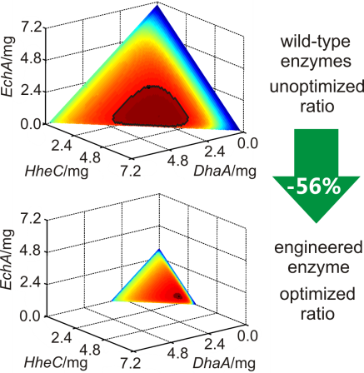 |  |  |  | Pavel Dvorak, Nagendra Prasad Kurumbang, Jaroslav Bendl, Jan Brezovsky, Zbynek Prokop, Jiri Damborsky *  Page No. – Page No.  Maximizing the Efficiency of Multi-enzyme Process by Stoichiometry Optimization

