Chapter 12

Hand Shape Recognition and Palmprint Recognition using 2D and 3D Features
Michal Dvořák, Martin Drahanský¹

1.1 Introduction
Many security systems of today use various biometrics to identify or verify identity of a given person, amongst most used ones, we often name fingerprint recognition, facial markers, iris or retina scans. These systems however, are not applicable in every situation either due to environmental, costs or other requirements arising from place or userbase. In these cases, other methods may be required. Hand geometry represents an alternative approach to human identification and verification. Due to its acquisition technology it may be used even in areas where, other technologies fail. Such us dust heavy environments, or the clean rooms that require glove use. Due to lower technological requirements, it may also prove to be a more affordable solution. Palmprint recognition on the other hand offers a technology that is more, preferable to users, as it does not have the bias the fingerprint technology has, despite the entropy level of extracted features being similar.
The principle and basis for hand based geometry and palmprint based recognition utilizes the assumption, that every individual possesses a unique hand, which upon analysis can be used to positively identify the user. In another word, if a reference shape of user’s hand is on record, this person’s identity can be established by comparing his immediate had shape or features of his palmprint with the one’s on the record. It was this assumption, that gave birth to first systems designed to do just so.
Identification of the characteristics that can be efficiently extracted without compromising the uniqueness requirement is the first necessary step, for chosen biometrics. 2D hand geometry and palmprint biometrics, serve of an abstraction of a model of human hand and define the array of features to be extracted. For hand geometry the features such as silhouette or various geometrical measurements, of width and/or thickness are recorded [1], whereas in palmprint recognition friction ridges (papillary lines) found on palm are used.
To increase the possible database sizes, and to improve security, the technology around these biometrics is still being improved on. One such direction of research and development is a modification of system from purely 2D acquisition and recognition to 3D. In order, to expand into a 3D system, a measurement of depth must be included, this then in turn allows parameters such as curvatures of individual fingers and 3D position of palmprint features to measured and recorded.

2.1 2D Hand Geometry Acquisition
2D hand geometry biometrics systems rank amongst oldest foray into identifications based on human measurements. Due to robustness, and space for further development, the systems based on this technology, can be found in many industrial productions and are still being developed. To understand the issues and advantages of hand biometrics, let’s first introduce the process of 2D acquisition.
Since for the identification only a silhouette of a hand is needed, the process of acquisition can be very simple. For this task, all that is required is camera sensor with adequate resolution. While for fingerprint sensor this resolution needs to be high due to the dimensions of papillary lines e.g. 500 DPI, the hand geometry systems require much lower resolution, in commercial systems 100-200 DPI sensors are used, but it has been demonstrated that even resolution as low as 100 DPI can be sufficient [2].
For 2D acquisition a back of a hand is usually captured on an image, from this image chosen features are then extracted. Some system utilize multiple sensors, to acquire images from different angles and thus making it possible to extract additional features [1]. As can be seen on Figure 1, majority of features is easily extractable when the camera is placed directly above scanned hand.
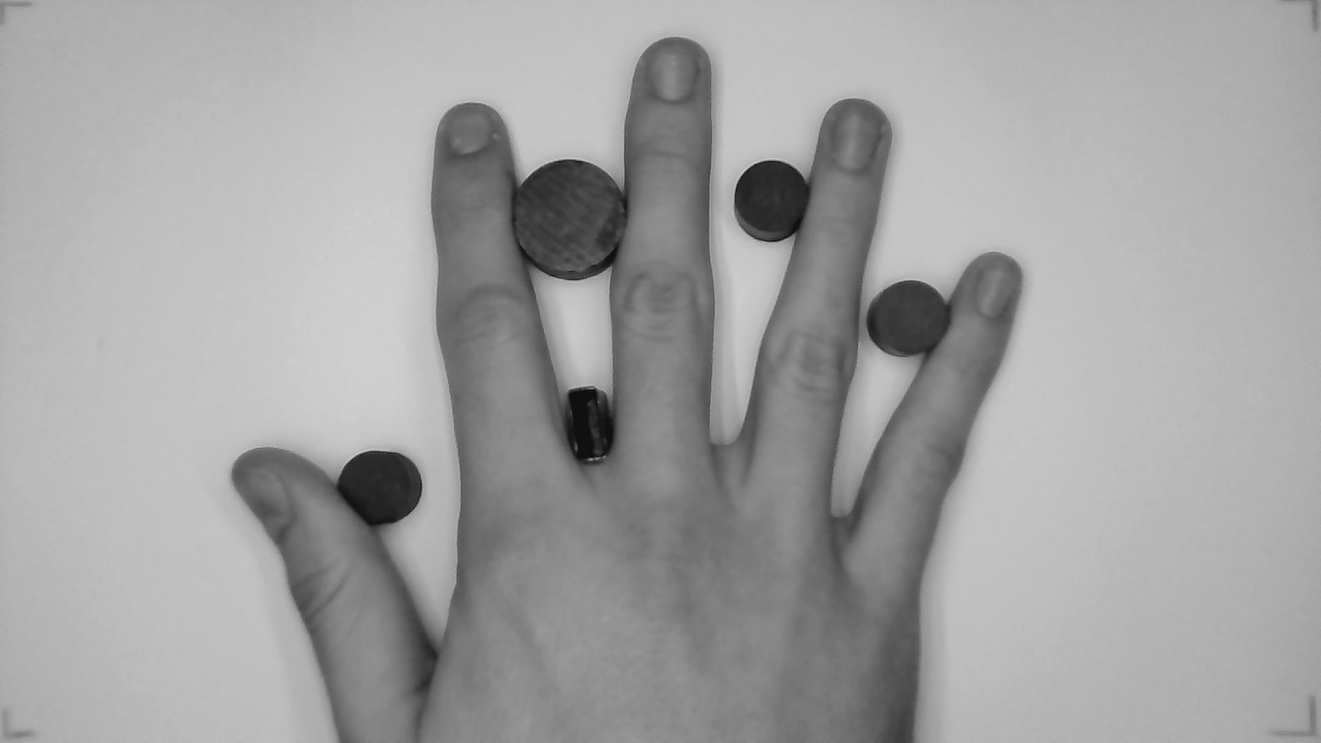
Figure 1a: Gathered image of a hand for 2D hand geometry extraction of features.

The acquisition process may be further enhanced by performing material modification to the device. Such as limiting the entrance of daylight, using artificial illumination and adding non-reflective background to limit the impact of shadows, all these modifications will make the preprocessing simpler. Figure 4 show possible set of features that can be extracted from the top view of the hand. All commercially available solutions today, are built around this approach.

2.2 Palmprint acquisition
Palmprint acquisition, can be realized using any technology for fingerprint acquisition. Due to advantages offered and the cost effectiveness, the optical approach is now used almost exclusively to the knowledge of the authors.
In the optical approach a camera of sufficient parameters is used to record an image. The parameters of this camera need to have sufficient resolution, to extract the papillary lines. While the sensor of 500DPI is recommended, the mobile phone cameras with resolution as low as 640 x 480px have been demonstrated to be sufficient for this acquisition [24].
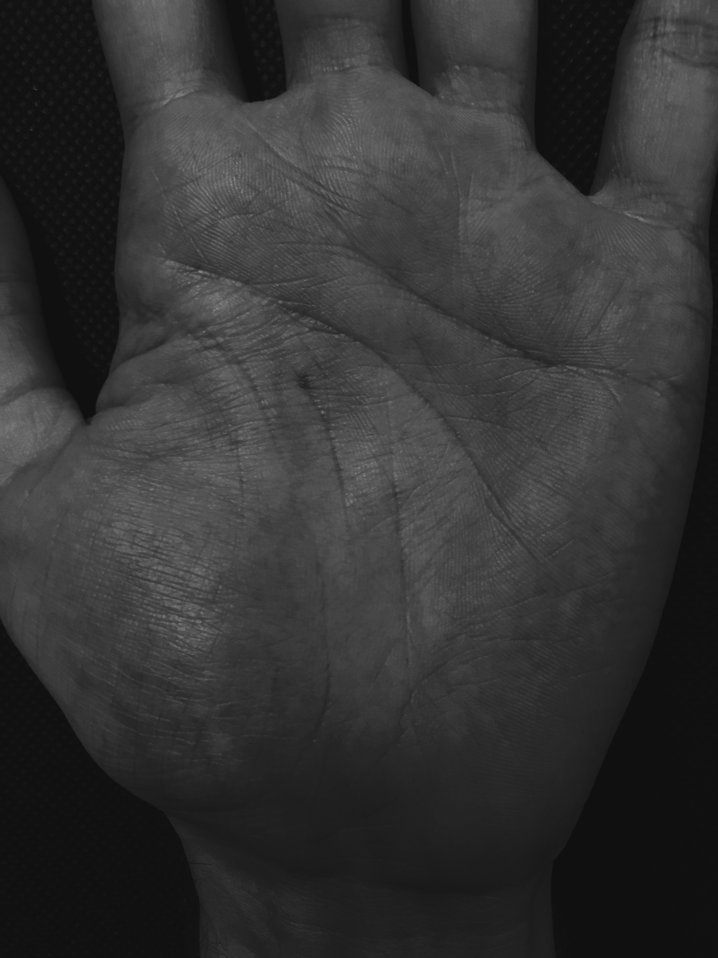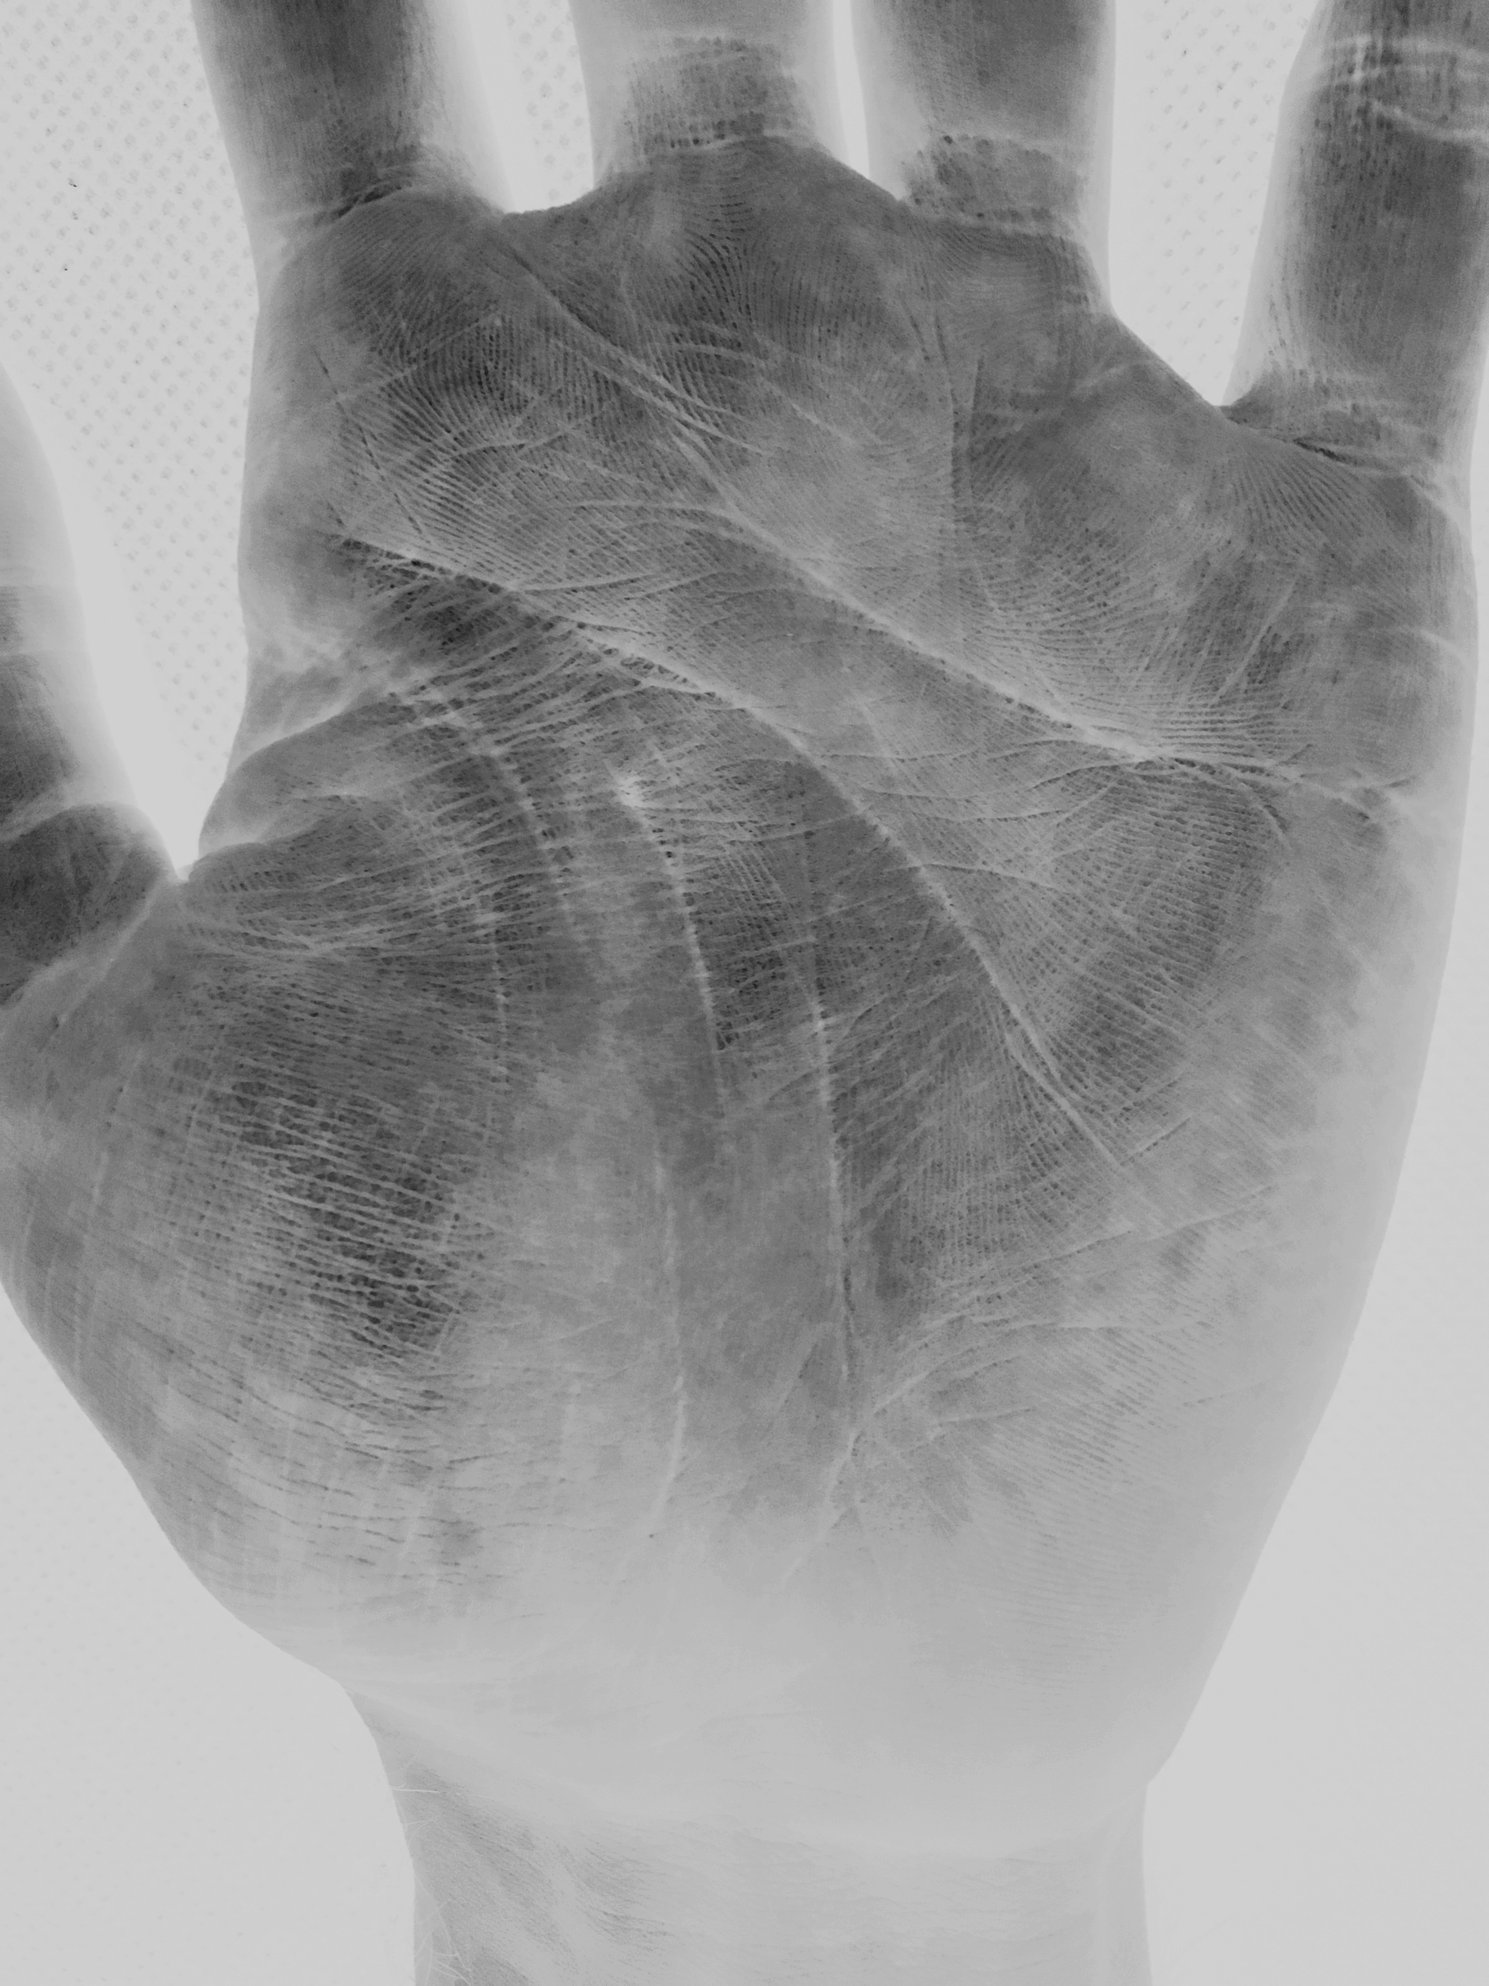
Figure 1b: Image of acquired palm(left) and after enhancement (right).

2.3 Existing commercial solutions for hand geometry biometry
To the best knowledge of authors, there are only two commercially available systems being currently developed, both by SCHLAGE. Line intended for use as a security admittance mechanism HandPunch® and line for time logging mechanism HandKey®.
At the time of writing this chapter, the newest model of the HandKey® series was HandKey II [3]. HandPunch GT-400 [4] and HandPunch 4000 then belong to the HandPunch® line [5]. HandKey II, as can be seen on Figure 2 is primarily designed as an access device, it is of sturdy construction and offers security features such as duress code. The base user memory of 512 user field can be further expandable. Per available information, the hand geometry features are stored as a 9-byte large compressed template.
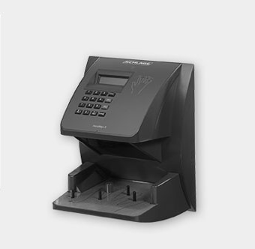
Figure 2: Image of HandKey II biometrics hand geometry reader [3].

The HandPunch series is primarily designed as an attendance and time logging terminal. HandPunch 4,000 also utilizes 9-byte large template, with default database size of 530 users, which can be expanded to 3,498. The HandPunch GT line is also intended as an attendance terminal. The main difference is in the size of the saved template, which is increased to 20-bytes from original 9. The device does not offer a database expansion, but the default size of 1000 users is larger than the base model of 4000 line. On Figure 3 the appearance of HandPunch device can be seen.
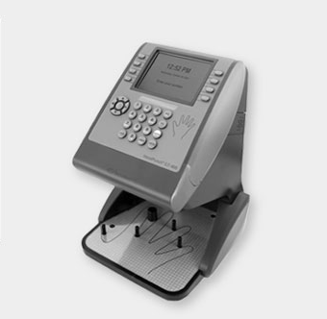
Figure 3: Image of HandPunch GT-400 biometrics hand geometry reader [4].

2.4 Commercially available solution for palmprint biometrics
To the best knowledge of authors, there is currently no ready to use solution commercially available on the market.
There is however a software solution available from Redrock Biometrics - PalmID that offers SDK for all major platforms [25].

2.5 Identification methods of hand geometry biometrics
Unlike fingerprint based biometrics, the hand geometry uses multiple different approaches to recognition. These approaches need to consider the fact, that there are multiple joints inside one hand, which allows for different position of individual fingers and their phalanxes on every image capture, this combined with fact that different pressure, placement or even physical state of the hand will make each reading unique and chosen method needs to take this under consideration. In general, we can split the today’s methods in two categories. Methods based on direct measurements of various hand parts, and hand shape alignment comparison.

2.5.1 Methods based on direct measurement
This method compiles a vector of dimensions of individual fingers and other parts of hand gained directly from the acquired image of a person’s hand. The example on Figure 4, shows configuration where 14 features are being inferred from a downward facing CCD sensor. Side facing camera is used to collect 2 additional dimensions. To the best knowledge of authors, all commercially available devices today use only the top view camera.
The extraction of features can be then done either by thresholding the image and gaining the dimensions straight from the binary image, alternatively, array of pixel values is taken from an unprocessed image and the features are determined individually. The second approach may prove advantageous, especially in case of localized skin discolorations, which can be incorrectly processed, if global or even local transformations are used. It is worth noting that if utilizing 2D imaging, increasing the number of features above certain threshold adds very little additional useful information for purposes of recognition.
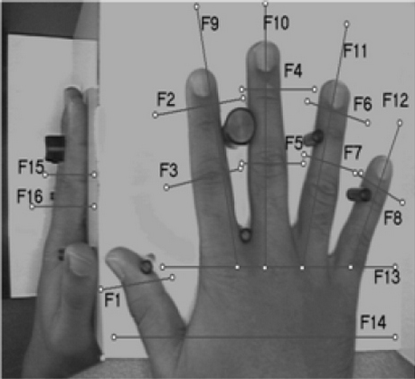
Figure 4: Viable hand 2D hand geometry features [2].

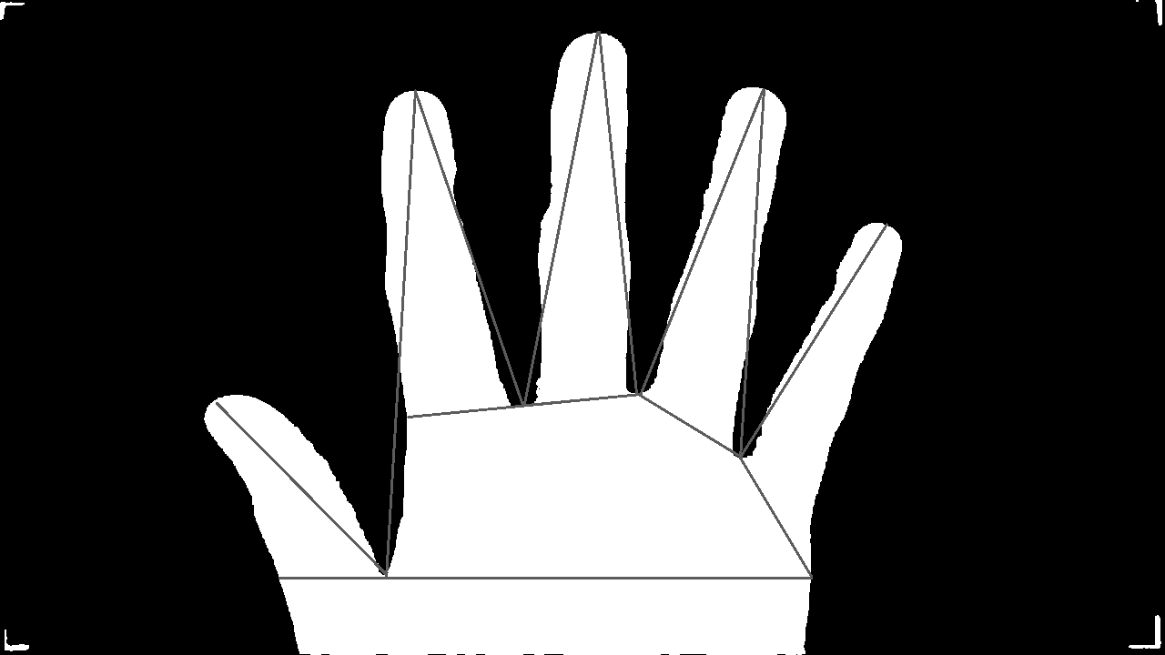
Figure 5: Other possible set of extractable features.

During enrolment one or multiple measurements are performed and saved as a model vector, which we then use during identification/verification phase where the model vector is matched against the newly acquired vector. Difference can be calculated using any metrics such as Sum of Absolute Difference (1), weighted Sum of Absolute Difference (2), Euclidian distance (3) or weighted Euclidian distance (4) [1]. The measured features x_{i} = [x₁, x₂, …, x_{z}], are then compared to template features y_{i} = [y₁, y₂, …, y_{z}] with σ_{i} being the weight of a given feature. While the usage of weights is not required, given the differences in absolute sizes of these feature, and difference in mobility of individual segments, it has proven to be beneficial.
i=1zxi-yi (1)
i=1zxi-yiσi (2)
i=1zxi-yi2 (3)
i=1zxi-yi2σi2 (4)
When using this method, the device usually includes positioning pins. These pins guide the hand into a position and simplifies the feature extraction, as the position will be, to an extent, guaranteed. If we attempted to locate chosen features, on an image of an unfixed hand, the pixel ranges for acquiring these features would need to be larger or dynamic, and in some cases, the uncertainty of features would increase as additional information would to be determined from the image, such as knuckle and joints positions and then used for feature extraction.
The pins however prohibit the technology from being touchless and dynamic, as the hand needs to come in contact with the pins and stay still for the duration of acquisition. This may be problematic for hygienic and medical reasons.
Alternative approach that allows unguided hand position is often based on silhouette matching.

2.5.2 Methods based on shape matching
Unlike the direct measurement approach, this method utilizes whole outline of the hand. The template is an outline itself or a normalized set of information that may be used for reconstruction.
The following steps describe the general approach to this method:
- Preprocessing
- Outline extraction. If the device is well designed, only thresholding is needed for object separation and then apply morphological operations to gain an outline of the hand.
- Extraction of individual fingers. To compensate for variable finger orientation, the outlines of individual fingers need to be extracted. The tips and valleys of the fingers can be searched for and the range of pixels between them is considered the finger. The orientation normalization can be performed here to prepare for next step.
- Perform alignment operations with the template. To do this, any algorithms that measures distance of two metric subspaces can be used, for example Modified Hausdorff Distance [6] where the orientation and position of one outline is gradually changed to achieve closest alignment with the template.
- Calculate the distance of the pair. MAE (Mean Alignment Error) can be calculated, as an average distance difference between corresponding points of the outlines.
- If MEA is less then threshold, it is declared the measured hand is of the same person as the one saved in template.

Figure 6, shows the principle of the comparison, outline is extracted from two hands, one during the enrollment process and other during the identification process. The template of the first is stored. During the identification we prepare a maximum possible overlap of individual fingers and calculate the MEA. Based on the resulting score, we decide whether the hand belongs to the same user. On Figure 6 (right), we can see that while the thickness of fingers displays a high degree of similarity, the length is different. Our threshold value should determine, that these two hands are not of the same individual
Both of the described methods serve the purpose they are designed for, both however are plagued by limitations we will look at now.
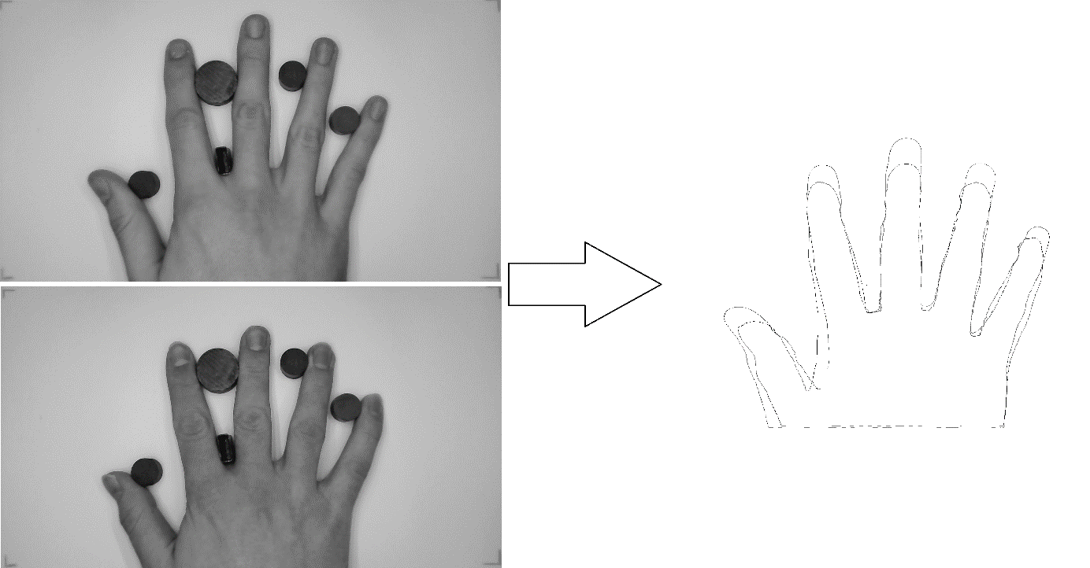
Figure 6 – Hand image used as a source and other hand image (left), outline overlap after finger positioning (right).

2.6 Identification methods of palmprint biometrics
Palmprint recognition is very similar to fingerprint recognition, in that is uses the friction ridges for feature extraction. The larger total area, can be seen both as an advantage and a disadvantage. It does offer greater number of identifiable features, which makes it potentially safer, at the same time, the device needs to be larger, and is often more expensive, hindering the adoption rate. The features we can extract depend on the design of the device, at lowest resolution, only the ridge flow and general patterns can be recorded, also known as Level 1. By increasing resolution smaller details can be used for features so called Level 2 details, such as ridge ending, bifurcation, dot, island, lake, hook, and variations. The further increase in resolution, allows for detecting path variation of ridges width and pores so called Level 3 details.
The detail level we acquire during the acquisition determines the palm matching method we use. For Level 1 details, simple template matching or correlation method will be used.
Minutiae matching uses the Level 2 details, the orientation and position of detected occurrences is noted and during verification, the matching score is determined by comparing the recoded features with the newly acquired. If the match rate is high enough based on predetermined score system, the hand is identified as a match. This is the currently most widely used method. Level 3 details can be used in ridge based matching, but is frequently used as complimentary source of features to the minutiae matching, and for liveliness detection.

2.7 Limitations of currently employed 2D based biometrics
While the lower requirements on the resolution of the sensor can make the system more cost effective and research shows that the resolution required for hand geometry can be further decreased [7], it also is a cause of several short comings that need to be addressed. We can split them into those, that can be solved or mitigated by modifying or improving on existing concept, and those that originate from the 2D acquisition itself, which makes them unsolvable without changing the basic concept.
The database size is a large issue for the hand geometry based technologies, as we can see from examination of commercially available solutions such as HandKey II [3], the focus on increasing viable database size is necessary for further spread of this technology. As has been discussed earlier in the chapter, increasing the number of features extracted from the 2D images, does not yield an adequate increase in the uniqueness. However, it has been demonstrated that, by including the 3D features of the hand, the entropy is increased, which in turn allows for larger user databases.
Just as the requirements for resolution are low, for these biometrics, so is the difficulty of developing a spoof that can be used to bypass this technology. The approaches to mitigating this risk will be elaborated on here. The palmprint recognition faces the similar issue, especially if the simple optical approach is used.
To increase the security of these systems, two approaches are being utilized and further researched. The first approach is to expand the unimodal system into multimodal system, where instead of recognition based solely on one biometrics, we use one or more of others, alternatively we use these additional biometrics simply as means of liveliness detection and focus solely on detecting their presence.
The liveliness detection, aims at measuring parameters, we expect to be present in a human hand, but not in a spoof. In case the system is developed as touch based, we commonly encounter checks based on electric properties, such as conductivity and capacity. Amongst other used we can encounter systems detecting heat, utilizing skin spectroscopy, odor analysis and high-resolution skin analysis to name a few.
For the system to remain touchless the vein detection can be utilized. The vein detection can either be performed as a surface detection, where by utilizing a near infrared light source (NIR) and performing an acquisition with a sensor without an IR filter i.e. Figure 8. We can detect veins on palm or dorsal part of hand as the optical absorption of NIR by hemoglobin is higher than that of other tissue and will appear darker on the resulting image.
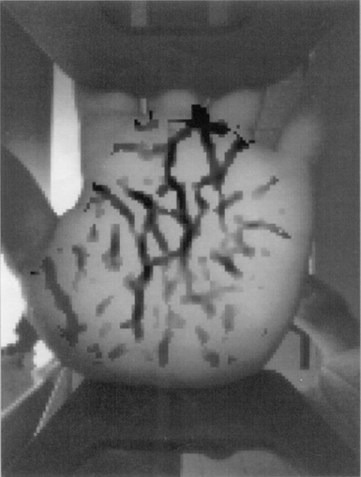
Figure 8: Surface vein detection using NIR.

Instead of capturing the reflection, system can instead capture the dispersed light passing through the hand as in Figure 9. Due to the hand structure, systems using this approach can detect the passing light on finger area only, otherwise a very strong light source would have to be used. As with the reflection approach, the NIR absorption by hemoglobin is used and the veins on the resultant image can be detected. Both these methods can be easily implemented into biometric system, as the NIR can be used as the sole source of the artificial lighting, and both CCD and CMOS sensors, have high sensitivity in the IR range of the electromagnetic spectrum. As stated earlier, the vein detection can be used solely as a liveliness detection, or a source of additional unique features.
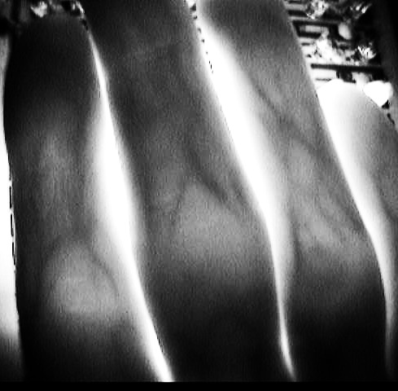
Figure 9: Vein detection using NIR light source behind object.

The other approach is to record the 3D as well as 2D features during enrollment and verification.
Both the transition from 2D to 3D and the multimodal approach can serve as a spoof protection, as the data required for construction of spoof are both less accessible and make the model reconstruction more complex. To the knowledge of authors, no study has demonstrated a 3D hand model or hand geometry with bloodstream model reconstruction from an uncooperative user with accuracy high enough to create a viable spoof.
As will be further discussed in the chapter, the transition from 2D to 3D biometrics has been experimentally accomplished and supports the assumption that 3D features will lead to increased entropy od the model.
To the extent of knowledge of authors, there are no existing pin-less and by extension contactless commercial devices for hand geometry recognition now available on the market. While it has been demonstrated that pure 2D approach can be used to remove the pin requirement for hand geometry recognition and the chapter presented one of such approaches. There is research into utilization of depth sensing devices, as a method of tackling this problem [9] as well as the need for the physical contact with the sensing device.

3.1 3D Acquisition of hand biometrics
The principle of 3D acquisition in biometrics has been successfully tested and researched. However, the price of hardware and high computational demands for processing this data, limited the application to academic research. With the advance of low-cost 3D acquisition devices, and increasing computational power of even the mobile devices, the 3D acquisition has become a viable alternative to 2D based systems. For hand geometry, the expansion into 3D offers additional source and type of features that can be extracted. For palmprint recognition the advantage lays in the feature description. Whereas in 2D based systems, the features location was defined using only two coordinates, the extension into 3D allows for three coordinates description, with serves both as a spoof protection and source of increased entropy.
Creative VF0800 low-cost camera [10] has been used to acquire the image at Figure 10. As we can observe the depth map, not only offers data for 3D feature acquisition, but due to the nature of the image, it allows for extraction of 2D features and even assists at the segmentation stages of the analysis, as the background is separated more clearly than on the illumination map. At the same time, the depth map allows us to determine the absolute dimensions of the recorded object, thus allowing for the freedom of position within the frame without losing any information regarding size.
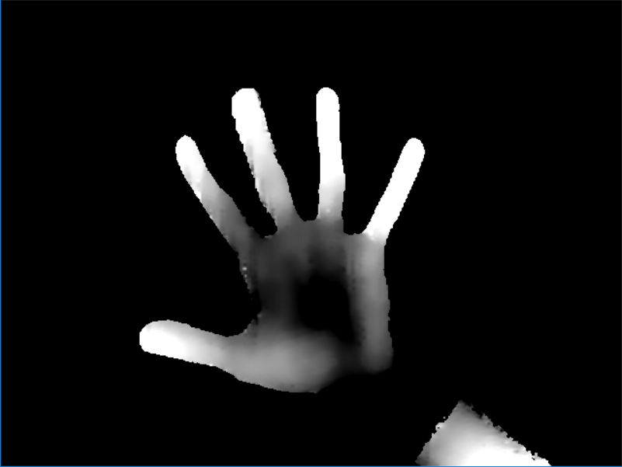
Figure 10: 3D image of hand using low cost 3D camera.

While any 3D mapping method may be used, in can be clearly observed that in current research, most utilized method is that of active triangulation. Whether the 3D laser digitizers are used for this purpose [11] and [12], which offer superior accuracy, or systems based on structured light projection [13] that are now being mass produced and are therefore affordable.

3.1.1 Using 3D scanner
In [11] high accuracy 3D scanner is employed – in this research Minolta Vivid 910 has been used for compilation of a large database of right hand scans (3,540 items). Per documentation, the device offers an accuracy up to 0.22 mm in x-axis, 0.16 mm in y-axis and 0.10 mm in z-axis [14].
Research done in [11] performs a detection of four fingers on intensity map, this information is then used for extraction of corresponding data from the depth map. Each fingers is then split into chosen amount of segments along the length of the finger. At these points the features such as curvature and normals along the finger are calculated based on the profile of the cross-section. Figure 11 shows a depth profile of a cross section, calculated curvature and normal features.
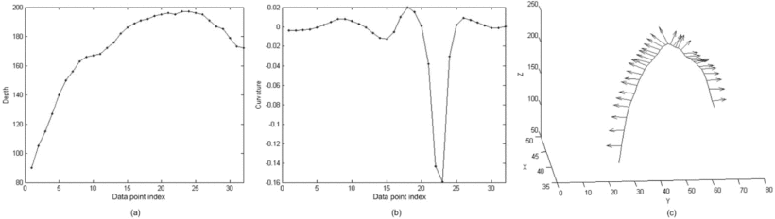
Figure 11: (a) Cross-sectional finger segment and (b) its computed curvature features; (c) Normal features computed for a finger segment [12].

In the paper, the 2D and 3D data are experimentally matched and EER (Equal Error Rate) and AUC (area under ROC curve) are calculated.
Matcher | EER [%] | AUC
3D Hand Geometry | 3.5 | 0.9655
2D Hand Geometry | 6.3 | 0.9722
(2D + 3D) Hand Geometry | 2.3 | 0.9888
Table 1: EER and AUC of 2D, 3D and a combined matcher [12].

From the data, it can be observed that the combination of 2D and 3D features offers an improved performance.

3.1.2 Using Structured Light
When a light pattern of an observable frequency is project onto a deformed surface such as human hand or palm, the pattern itself becomes apparently deformed. By detecting and measuring this deformation relative to the non-deformed pattern a 3D mesh can be reconstructed that serves as a model of observed object. This approach using active triangulation has been used in several publications, varying both in the type of light and the pattern used.

3.1.2.1 IR pattern projection
Utilizing IR camera and IR projector became viable thanks to the mass production of affordable 3D sensing technologies for purposes of entertainment, such as Microsoft Kinect and Intel RealSense. Both aforementioned devices include not only the depth sensor, but also standard RGB imagining sensor, with software libraries, that map the coordinates of one onto the other.
In [12] 2D and 3D features of human hand are extracted using Intel Real Sense camera. After normalizing the image during preprocessing, markers such as fingertips, finger valleys and wrist lines are located. Using these markers feature vectors containing 41 2D features and 137 3D features are constructed.
- Finger length (2D)
- Finger valley distance (2D)
- Finger width (2D)
- Wrist to valley distance (2D)
- Finger axis surface distance (3D)
- Finger width (3D)
Figures 12 and 13 shows the respective features on the depth images and intensity images.
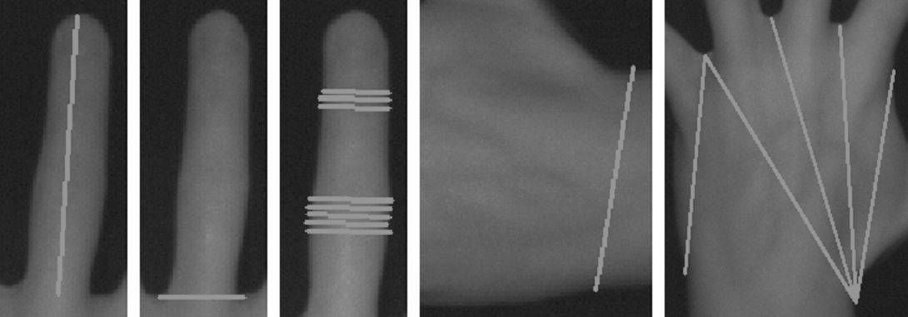
Figure 12: Extracted 2D features [13].
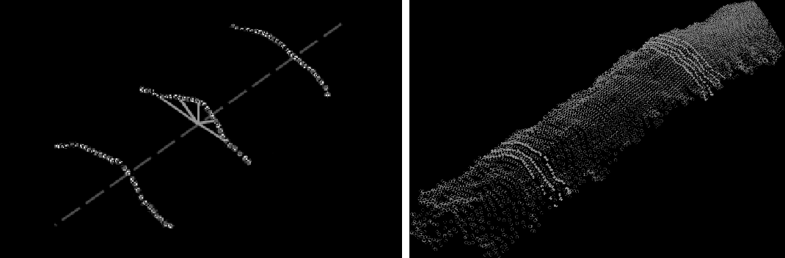
Figure 13: Extracted 3D features [13].

The matching of the features vectors is performed using Mahalanobis distance [15], where the weights for individual features are calculated using the large margin nearest neighbors method (LMNN) [16].
In the paper 2D and 3D feature vectors are calculated separately, this allowed the authors to compare both the performance of individual vectors and the combination of two. The results can be seen in Table 2.
 |  | FRR [%]
Features | ERR [%] | @FAR = 0.5% | @FAR = 1%
2D | 2.76 | 6.50 | 1.63
3D | 2.92 | 10.70 | 6.42
2D + 3D | 1.61 | 4.81 | 2.23
Table 2: Overall performance of Bronstein and Drahansky system using LMNN metric learning approach [12].

Unlike in the experiment with the high precision 3D scanner, the performance of only 3D features in recognition algorithm is inferior to the 2D hand based geometry biometric. However, the performance of combined features, is superior to a 2D only approach by a large margin, despite using the low-cost technology. It is also worth noting, that the performance is significantly higher, when one source of features is burdened by heavy noise, as one technology can be immune to source of noise, that the other is burdened by, i.e. glare in RGB sensor does not influence the depth mapping. Overall the combination of 2D and 3D feature vectors in the algorithm has demonstrated performance comparable to the state of the art approaches.
Method | Features | Templates | Database | FAR [%] | FRR [%] | EER [%]
Jain and Duta | 2D | 1 – 14 | 53 | 2.00 | 3.50 | N/A
Jain et al. | 2D | 1 (avg) | 50 | 2.00 | 15.00 | N/A
Woodard and Flynn | 2D + 3D | 1 (avg) | 177 | 5.50 | 5.50 | 5.50
Malassiotis et al. | 2D + 3D | 4 | 73 | 3.60 | 3.60 | 3.60
Kumar et al. | 2D + 3D | 5 | 100 | 5.30 | 8.20 | N/A
Kanhangad et al. | 2D + 3D | 5 | 177 | 2.60 | 2.60 | 2.60
Bronstein and Drahansky | 2D + 3D | 1 (avg) | 88 | 1.61 | 1.61 | 1.61
Table 3: Qualitative comparison of hand biometrics based matchers [12].

3.1.2.2 Lasers and diffraction grating
While the utilization of commercial low-cost cameras has demonstrated acceptable results, the fact that these devices are designed to operate at wider range of distances and greater depth of field means, that the principle can be optimized for the specific application. Since we also have the information about the range of colors we can expect from human hand, a specific wavelength can be chosen to better match the intended application.
In [17] the array of 532 nm lasers is being used, with optics that changes the dot projector into the line projector thus producing number of parallel lines. For the image acquisition two MS Lifecam HD 3000 camcorders are used. From the acquired images, the model of hand can be reconstructed. The Figure 14 shows the process of segmentation and feature extraction during the experiment.
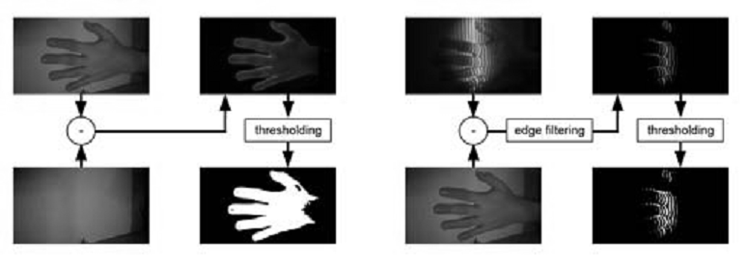
Figure 14: The process of extracting the deformation markers, created by diffracting line projection [17].

The Figure 15 presents a model reconstructed from the acquired data, demonstrating the concept.

Figure 15: Resultant surface reconstruction from the lines projection [17].

The paper serves as the proof of concept and viability study of the method for the purposes of 3D hand geometry scanning, as such, database has not been created and method cannot be compared with other available approaches. The accuracy of method has been demonstrated by scanning calibrated object of known dimensions. For this purpose, a cube with a side of length 25.5 mm has been used and the root mean squared, and normalized root mean squared has been calculated as can be seen in Table 4.
Model | NRMSE | RMSE
Laser 0 | 0.2190 | 1.4558
Laser 1 | 0.1993 | 0.7977
Laser 2 | 0.1764 | 0.4317
Merged | 0.1764 | 1.0474
Table 4: Accuracy of the proposed method based on calibration [17].

3.1.3 Time of flight (TOF) scanning
TOF cameras due to the principle of their operation and the costs, were for a long time more suitable for industrial applications. However, as low-cost systems such as SoftKinetic’s DS325 and Kinect v2 RGB-D have been introduced, their utility became much wider, despite the limitations.
While the research in hand biometry using the TOF has been limited to gesture detection. It has been demonstrated, that the technology is viable for biometric recognition uses as well, especially with regards to face recognition. In [18] the TOF cameras has been used to capture a depth map of user’s facial features, and compared to results from other technologies, as can be seen on Figure 16. As expected, the minute details are lost to high degree of noise.
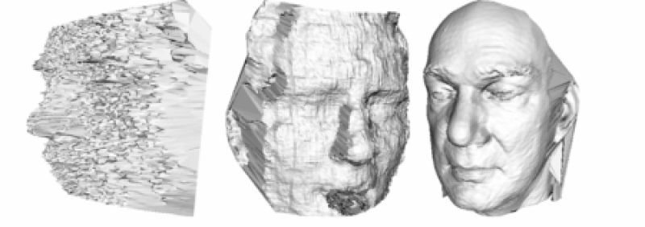
Figure 16: Example 3D acquisition using TOF cameras SoftKinetic (left), Kinect (middle) and professional Minolta Vivid scanner (Right) [18].

The research however demonstrated, that using feature preserving mesh denoising methods can be used to suppress the noise and improve the signal to noise ratio enough for an extraction of biometrics features, usable for biometric identification, as can be seen on Figure 17.
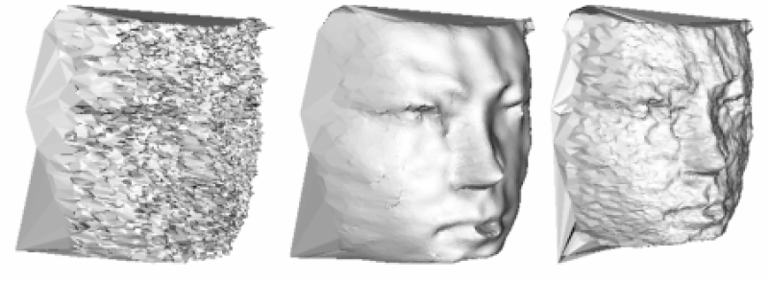
Figure 17: High noise DS325 image (left), after application of feature preserving mesh denoising (middle) and Gaussian smoothing (right) [18].

3.1.4 Stereo vision approach
Stereovision is a process where, by combining information from two stationary cameras, we can determine a depth in an image via the method of passive triangulation. The passive triangulation uses the position difference of significant points on the pair of images, to determine the distance to sensors. If the resolution is high enough and therefore the number of point pairs is sufficient, a shape of the observed object, in our case the human hand, can be reconstructed.
At the moment, there are multiple commercially available 3D cameras, based on the stereoscopy principle, with resolution high enough for the biometric purposes. For example, ENSENSO N10-304-18 can per documentation achieve the resolution in Z axis of up to 0.109 mm [19]. Unlike TOF based technology, the acquisition time can be as low as a time to capture one image, and under proper conditions, can offers higher precision, than active triangulation via the subpixel methods. The largest source of error for this technology is a lack of detectable significant point pairs on homogenous or smooth surfaces, this however does not apply to human hand, as the papillary lines themselves, offer the necessary irregularities for significant point pair identification.
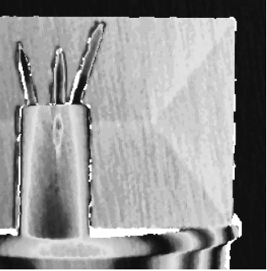
Figure 18: Example of 3D image created using stereovision [20].

4 Utilization of line scanners in biometric acquisition
Direction in research currently explored by the authors, is the utilization of line scanners for 2D and 3D acquisition of multimodal hand biometrics. Where the main advantage comes in the form of ability to performing dynamic acquisition. The principle of operation of line scanner, which records many one-line wide segments at high speed, allows for recoding high-resolution images while the scanned hand is in motion. This in turn allows for development of high throughput biometric gates, without compromising the image quality. The high-quality image, then can be used to extract additional biometrics, such as fingerprints and palmprints and the same time.

4.1 Camera system
The proposed parameters of this system, are to allow an image acquisition of such quality, so that, 2D hand geometry, fingerprints and palmprints may be extracted from acquired image. Minimum speed of the moving hand, that must be supported by the solution, has been decided as 0.5 ms⁻¹.
To meet these requirements, a line scanner resolution must provide at least 500 DPI on the cross-section of at least 200 mm, this translates to minimum resolution of at least 4,000 pixel. To meet the vertical resolution requirement, the sensor must have a minimum framerate of 10 kHz.
The raL6144-16gm – Basler racer [21] provides resolution of 6,144 pixel, sufficient for the designed purpose and 17 kHz frame rate, which allows for maximum hand speed of 0.85 ms⁻¹. Secondary reason for choosing this model is the sensor size of 43 m, allowing for utilization of full frame optics.
AF Nikkor 50mm f/1.8D has been chosen for the camera lens, as it has an acceptable minimum focal length of 45cm and f-number that supports depth field necessary for touchless solution.

4.2 Proof of concept
In Figure 19 a) an image acquired using fixed line scanner with a hand on a moving platform is shown. The hand on the image is moving at the speed of 0.5ms⁻¹. Figure 19 b) is just an extracted area of interest from Figure 19 a) showing a detail of a ring finger. It can be observed that papillary lines ale clearly visible, meeting the requirement for possible fingerprint feature extraction and 2D hand geometry features. The latter, is demonstrated on Figure 20.
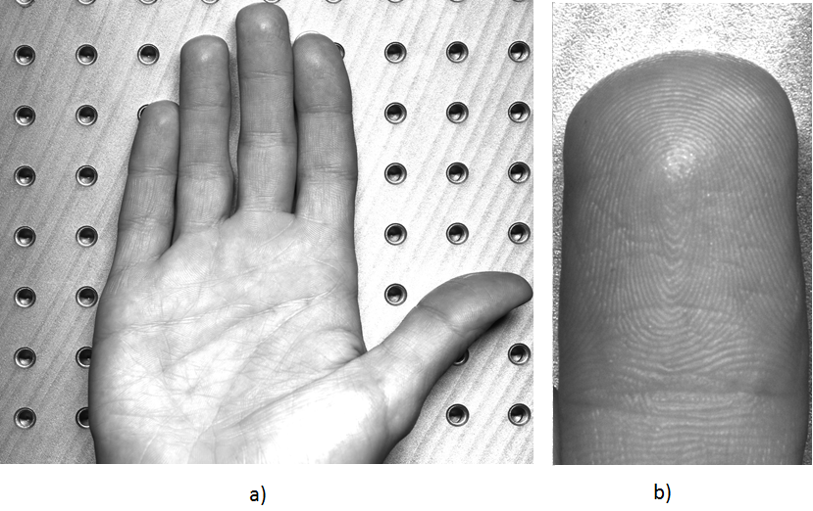
Figure 19: a) Palmprint using line scanner mounted on moving platform; b) detail of ring finger.

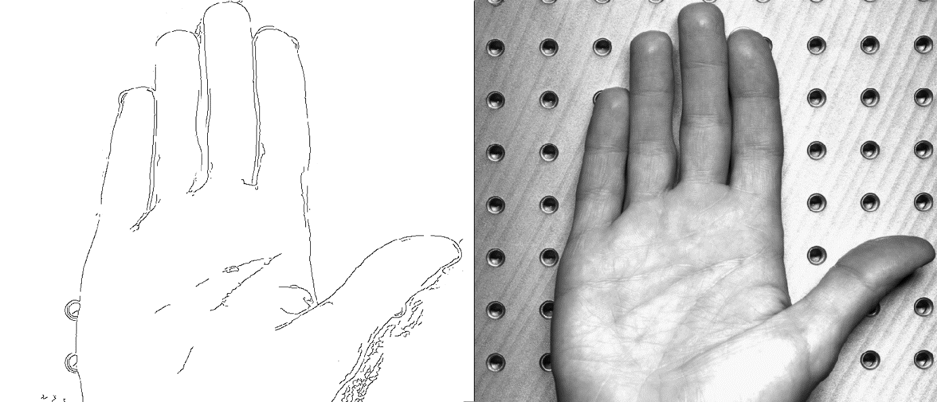
Figure 20: Mask filtering and edge detection used to extract outline (left) from an image of hand acquired via line-scanner (right)

For fingerprint extraction a commercial tool VeriFinger [22] has been used to verify the concept. A detail of finger has been taken from the image and processed using VeriFinger. As can be seen on Figure 21, VeriFinger was able to successfully perform segmentation and extract large number of unique features that can be used for identification purposes. As the setup used was designed as a proof of concept only, voids can be observed on the segmented image, where the light on the original image caused a glare. The usability of this setup for fingerprint extraction has been successfully demonstrated.
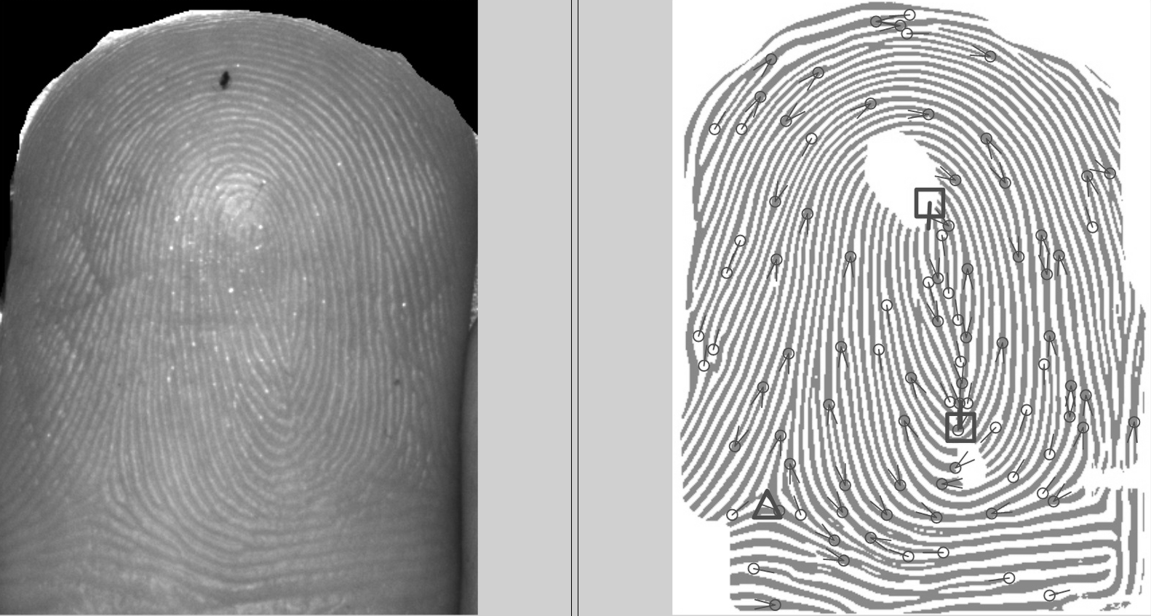
Figure 21: Fingerprint image using line scanner (right), extracted fingerprint using VeriFinger SDK (right).

Figure 22 presents a detail of palm and a preprocessed image with enhanced papillary lines. While a level of noise can be noted, the features for palmprint recognition are also visible, meeting the requirements placed on the POC.
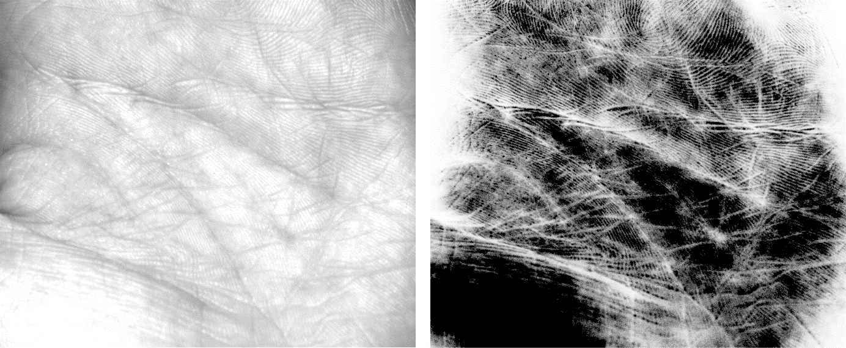
Figure 22: The POC palmprint extraction from the image, source image (left) and pre-processed palmprint (right).

4.3 Reconstruction of hand image in touchless system
As the proof of concept with the line scanner was successful, the current direction of development lies in the image acquisition of hand that performs an uncalibrated movement. Based on the proof of concept a camera system, that allows a free hand movement has been constructed. The setup is presented on Figure 23.
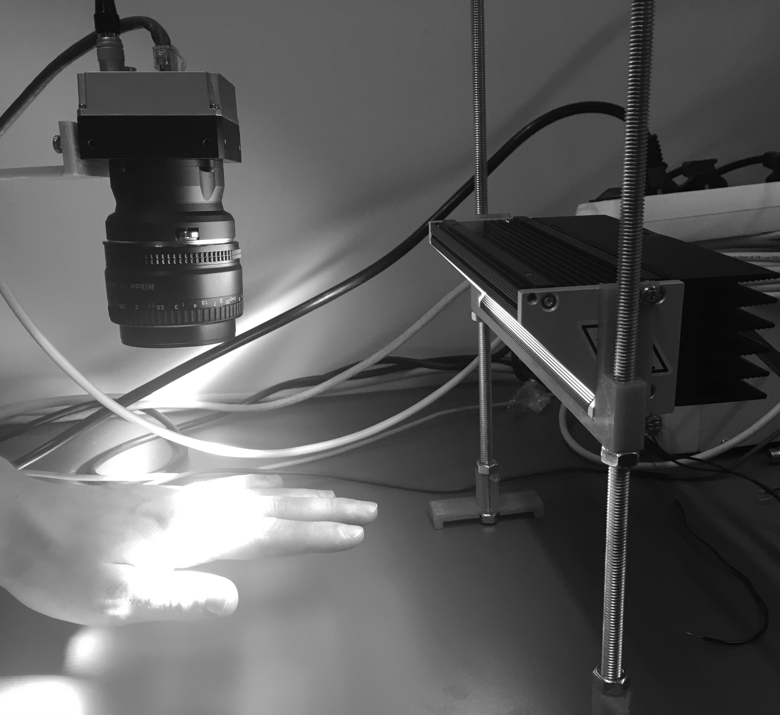
Figure 23: Setup of system with free hand movement.

Initial experimentation with this setup has been performed and is presented on Figure 24 the deformations are caused by non-perfect reconstruction of acquired data, the details on Figure 24 a) and b) demonstrate, that the detail level has been retained for required feature extraction.
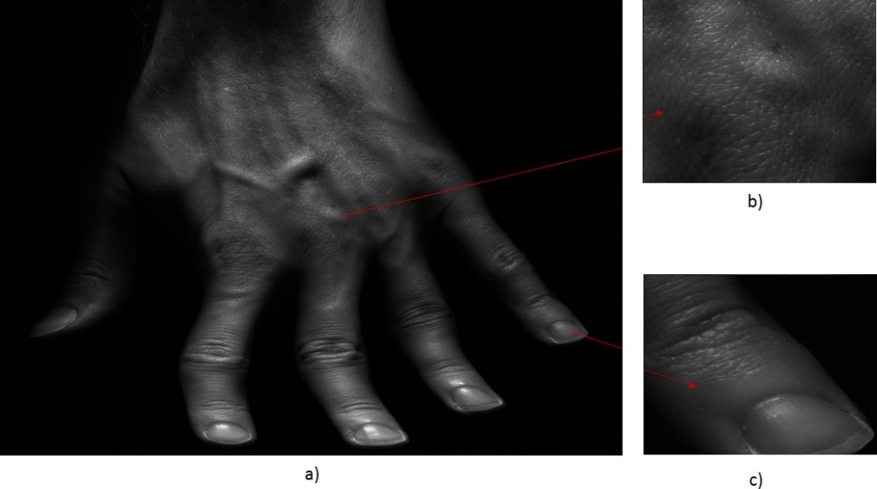
Figure 24: a) Handprint using a fixed line scanner scanning a moving hand; b) detail of middle knuckle; c) detail of little finger.

4.4 Utilization of 3D line scanner in 3D biometrics feature extraction
Future direction of research, lies in expanding the above described technologies into 3D line scanning. Combination of stereovision and line scanner technology for biometric application is currently being explored and developed. For the proof of concept development, 3D PIXIA [23] 3D line scanner has been acquired and is being tested. With the resolution of up to 10um in z-axis and high frame rate of up to 21kHz, the 3D mapping resolution is high enough to capture a high-quality model of human hand that will be usable for 3D hand geometry and palmprint extraction. As of now, only preliminary preparation has been made.
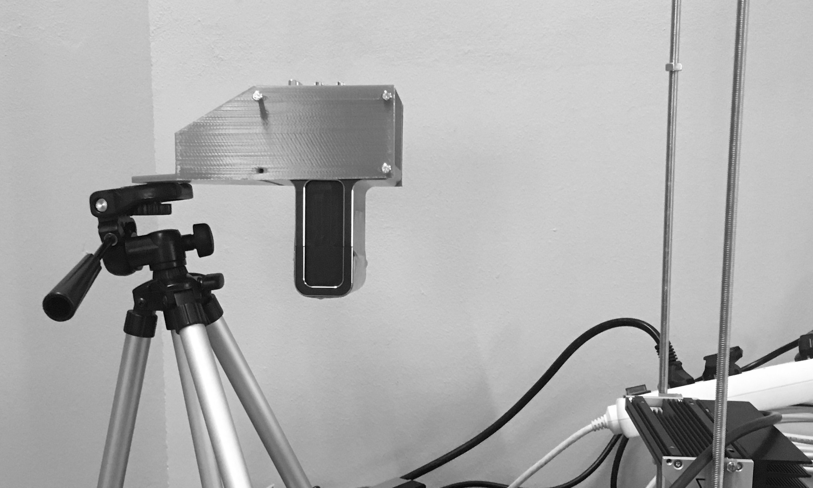
Figure 25: Preview of 3DPIXA setup for 3D line scan acquisition.

5 Conclusion
In this chapter the current state of palmprint and hand geometry based biometrics has been presented. The most used methods of acquisition, feature extraction and subsequent identification have been described as well as the current state of the commercially available solutions based on these technologies. The limitations of 2D biometrics have been discussed along with possible approaches to solving them.
3D scanning techniques utilized in biometrics, have been introduced and described along with their complimentary nature to the 2D methods. The current development in this area has been outlined.
Novel multimodal method of biometric image acquisition utilizing the line scanner has been introduced, with the experimental results from the proof of concept system demonstrating the capability of hand geometry, fingerprint and palmprint features extraction. The future development direction has been outlined by introducing a 3D line scanner and justifying its specification with the required task in mid.
The palmprint and hand geometry are two technologies that are often being overlooked in favor of alternatives, despite their advantages. With the advance of cheaper sensing technologies, and higher available computing power, some of the shortcoming are being overcome. By expanding these systems into 3D, in a fast and affordable way, these biometrics, may very well soon gain in popularity.

Acknowledgement
This work was supported by The Ministry of Education, Youth and Sports of the Czech Republic from the National Programme of Sustainability (NPU II); project IT4Innovations excellence in science – LQ1602.

6 References
[1] M. Drahanský, F. Orság et al. Biometrie. Brno: Computer Press, 2011. ISBN 978-80-254-8979-6.
[2] A. K. Jain, A. Ross, S. Pankanti, "A prototype hand geometry-based verification system", Proc. AVBPA, pp. 166-171, 1999.
[3] HandKey II. Allegion [online]. Dublin, Ireland, 2014 [cit. 2017-04-25]. Available at: http://us.allegion.com/Products/biometrics/handkey2/Pages/default.aspx
[4] HandPunch GT-400. Allegion [online]. Dublin, Ireland, 2014 [cit. 2017-04-25]. Available at: http://us.allegion.com/Products/time_attendance/g_series/gt400/Pages/default.aspx
[5] HandPunch 4000. Allegion [online]. Dublin, Ireland, 2014 [cit. 2017-04-25]. Available at: http://us.allegion.com/Products/time_attendance/f_series/hp_4000/Pages/default.aspx
[6] Dubuisson, M-P., and Anil K. Jain. "A modified Hausdorff distance for object matching." Pattern Recognition, 1994. Vol. 1-Conference A: Computer Vision & Image Processing, Proceedings of the 12th IAPR International Conference on. Vol. 1. IEEE, 1994.
[7] M. A. Ferrer, J. Fabregas, M. Faundez, J. B. Alonso and C. Travieso, "Hand geometry identification system performance," 43rd Annual 2009 International Carnahan Conference on Security Technology, Zurich, 2009, pp. 167-171.
[8] H. Chen, H. Valizadegan, C. Jackson, S. Soltysiak, A.K. Jain, Fake hands: spoofing hand geometry systems, Biometric Consortium 2005, Washington DC, 2005
[9] Sung-Il Joo, Sun-Hee Weon, and Hyung-Il Choi, “Real-Time Depth-Based Hand Detection and Tracking,” The Scientific World Journal, vol. 2014, Article ID 284827, 17 pages, 2014. doi:10.1155/2014/284827
[10] Intel RealSense™ Camera [online]. 2015, [cit. 2017-04-17]. Available at: https://software.intel.com/en-us/RealSense/SR300Camera
[11] V. Kanhangad, A. Kumar and D. Zhang, "Combining 2D and 3D hand geometry features for biometric verification," 2009 IEEE Computer Society Conference on Computer Vision and Pattern Recognition Workshops, Miami, FL, 2009, pp. 39-44.
[12] V. Kanhangad, A. Kumar and D. Zhang, "A Unified Framework for Contactless Hand Verification," in IEEE Transactions on Information Forensics and Security, vol. 6, no. 3, pp. 1014-1027, Sept. 2011.
doi: 10.1109/TIFS.2011.2121062
[13] J. Svoboda, M. Bronstein and M. Drahanský. Contactless biometric hand geometry recognition using a low-cost 3D camera. In: Proceedings 2015 International Conference on Biometrics. Phuket: IEEE Biometric Council, 2015, pp. 452-457. ISBN 978-1-4799-7824-3.
[14] Vivid 910: Non-contact 3D digitizer [online]. In: . 2002, s. 6 [cit. 2017-04-17]. Available at: http://www.upc.edu/sct/documents_equipament/d_288_id-715.pdf
[15] Mahalanobis, Prasanta Chandra (1936). "On the generalised distance in statistics" (PDF). Proceedings of the National Institute of Sciences of India. 2 (1): 49–55. Retrieved 2016-09-27
[16] Weinberger, K. Q.; Blitzer J. C.; Saul L. K. (2006). "Distance Metric Learning for Large Margin Nearest Neighbor Classification,". Advances in Neural Information Processing Systems. 18: 1473–1480
[17] J. Svoboda, O. Klubal and M. Drahanský, "Biometric recognition of people by 3D hand geometry," The International Conference on Digital Technologies 2013, Zilina, 2013, pp. 137-141.
[18] Mráček, Štěpán, et al. "3D face recognition on low-cost depth sensors." Biometrics Special Interest Group (BIOSIG), 2014 International Conference of the. IEEE, 2014.
[19] Ensenso N10. Imaging development systems [online]. Obersulm, Germany [cit. 2017-04-25]. Available at: https://en.ids-imaging.com/ensenso-n10.html
[20] Nové modely 3D kamer Ensenso. Analyza obrazu [online]. 2015 [cit. 2017-04-25]. Available at: http://www.analyza-obrazu.cz/aktuality/nove-modely-3d-kamer-ensenso/
[21] RaL6144-16gm - Basler racer. Basler: The power of sight [online]. Germany [cit. 2017-04-25]. Available at: https://www.baslerweb.com/en/products/cameras/line-scan-cameras/racer/ral6144-16gm/
[22] VeriFinger SDK. Neurotechnology [online]. [cit. 2017-04-25]. Available at: http://www.neurotechnology.com/verifinger.html
[23] 3D Line Scan Camera 3DPIXA compact 30µm. Chromasens [online]. [cit. 2017-04-30]. Available at: https://www.chromasens.de/en/product/3d-line-scan-camera-3dpixa-compact-30um
[24] CHORAŚ, Michał a Rafał KOZIK. Contactless palmprint and knuckle biometrics for mobile devices. Pattern Analysis and Applications [online]. 2012, 15(1), 73-85 [cit. 2017-11-02]. DOI: 10.1007/s10044-011-0248-4. ISSN 1433-7541. Dostupné z: http://link.springer.com/10.1007/s10044-011-0248-4
[25] PalmID. PalmID [online]. San Francisco, CA, 2017 [cit. 2017-11-02]. Available at: http://redrockbiometrics.com/.

Brno University of Technology, Faculty of Information Technology, Centre of Excellence IT4Innovations

